LOCKOUT/TAGOUT DEVICES
This appendix includes examples of lockout/tagout devices that may be utilized within the scope of the University of Oregon’s Lockout/Tagout Program. Machinery and equipment must be de-energized and locked/tagged out at the source(s) of the energy before maintenance, repair, or modifications can be made. Lockout/tagout devices are placed to prevent the re-energization of equipment before work is complete. Example lockout/tagout devices include:

- Example lockout lock and key:

- Example tagout tag:
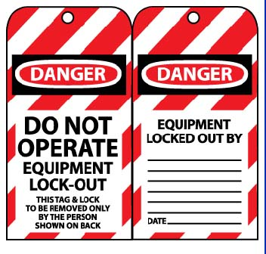
- Example breaker lockout:
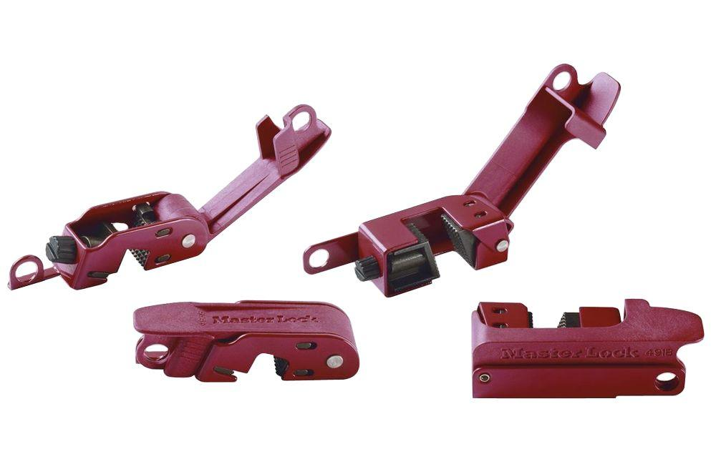

- Example switch lockout:
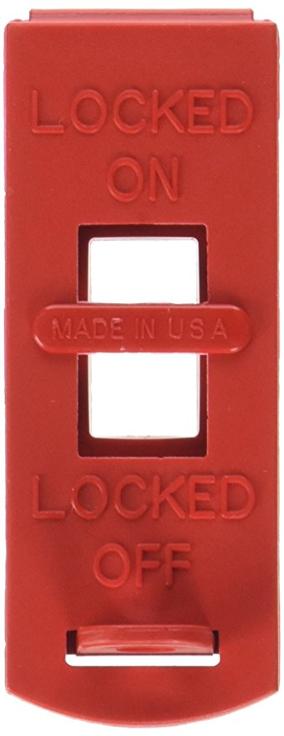
- Example plug lockout:
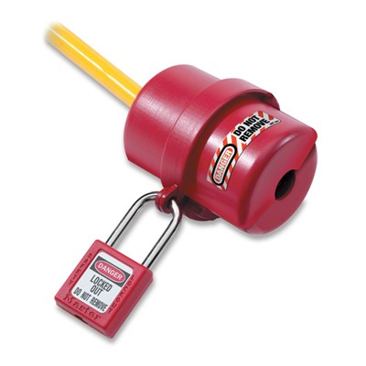
- Example adjustable cable lockout:
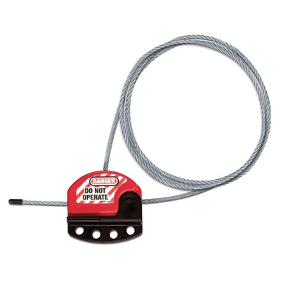

- Example gate valve lockout:
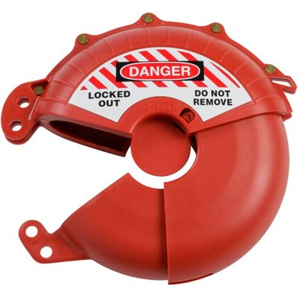
- Example plug valve lockout:
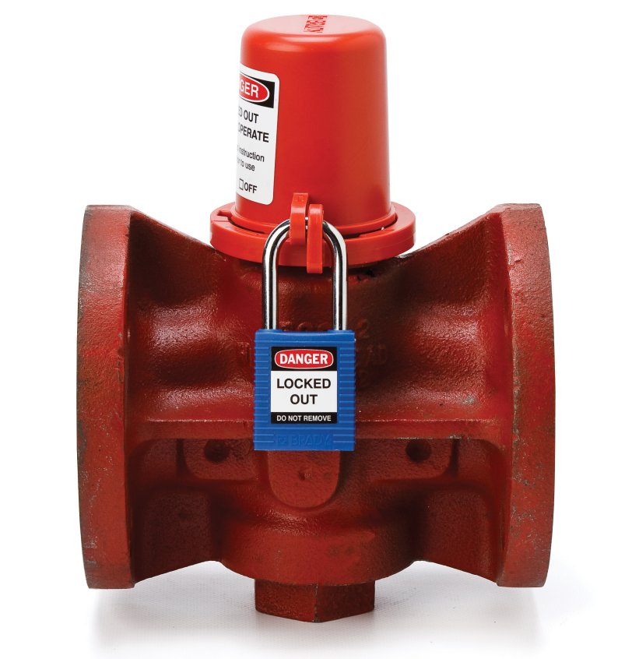

- Example pneumatic fitting lockout:
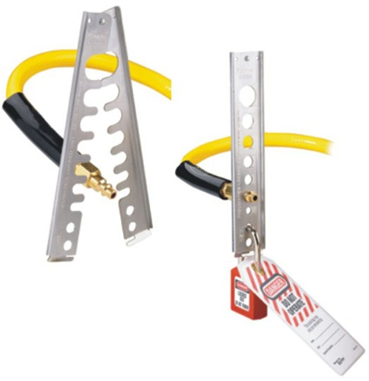

- Example hasp lockout (for groups):
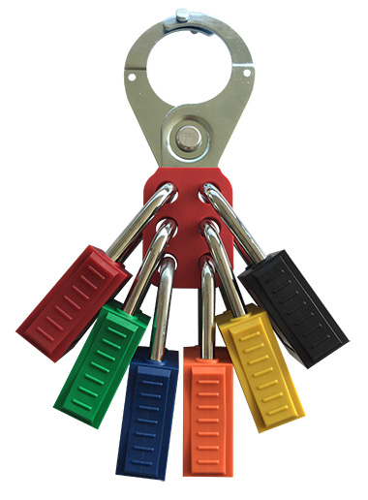
- Example group lockout box:
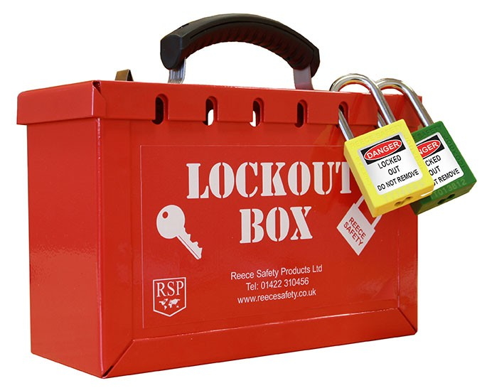
- Example workplace lockout station:

