SAMPLE LOG BOOKS:
This appendix gives examples of department specific lockout log books within the scope of the University of Oregon’s Lockout/Tagout Program. Machinery and equipment must be de-energized and locked/tagged out at the source(s) of the energy before maintenance, repair, or modifications can be made. Employees using lockout/tagout devices will record their use within their department’s log book.

- Example blank Utilities & Energy lockout log book:

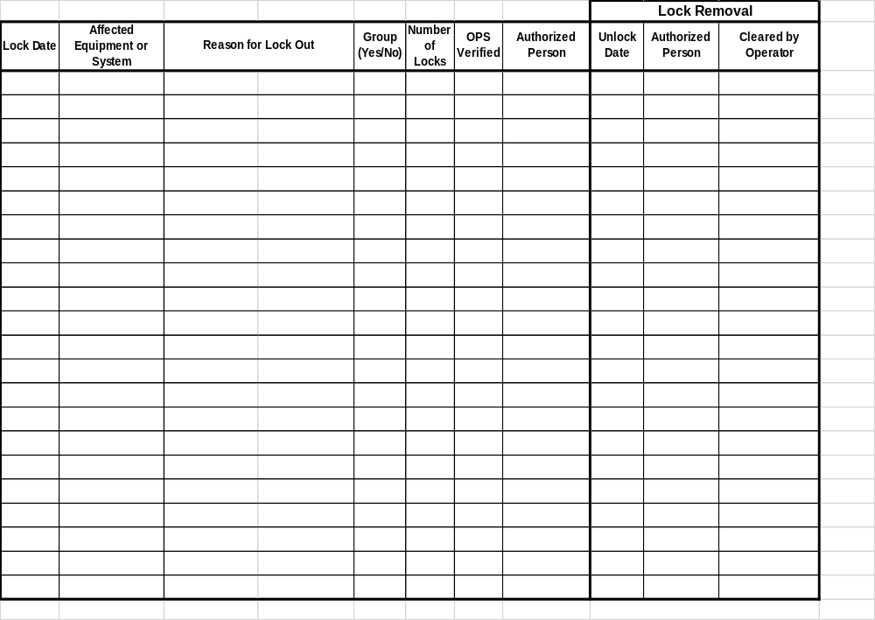

- Example in-use CPFM lockout log book:

