Submitting and Updating a COI Disclosure in the
the Research Administration Portal
- After logging into the Research Administration Portal (RAP), select the “COI” module.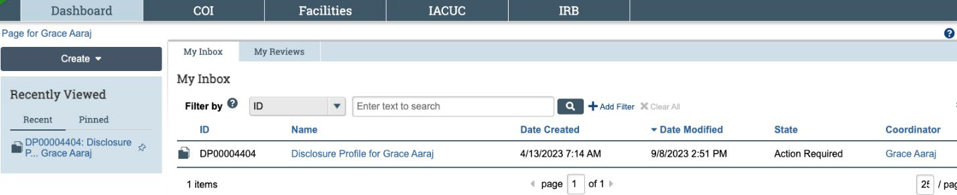
- You are now in the Disclosure Profile workspace. Select “Edit Disclosure Profile.” A pop-up window will appear.
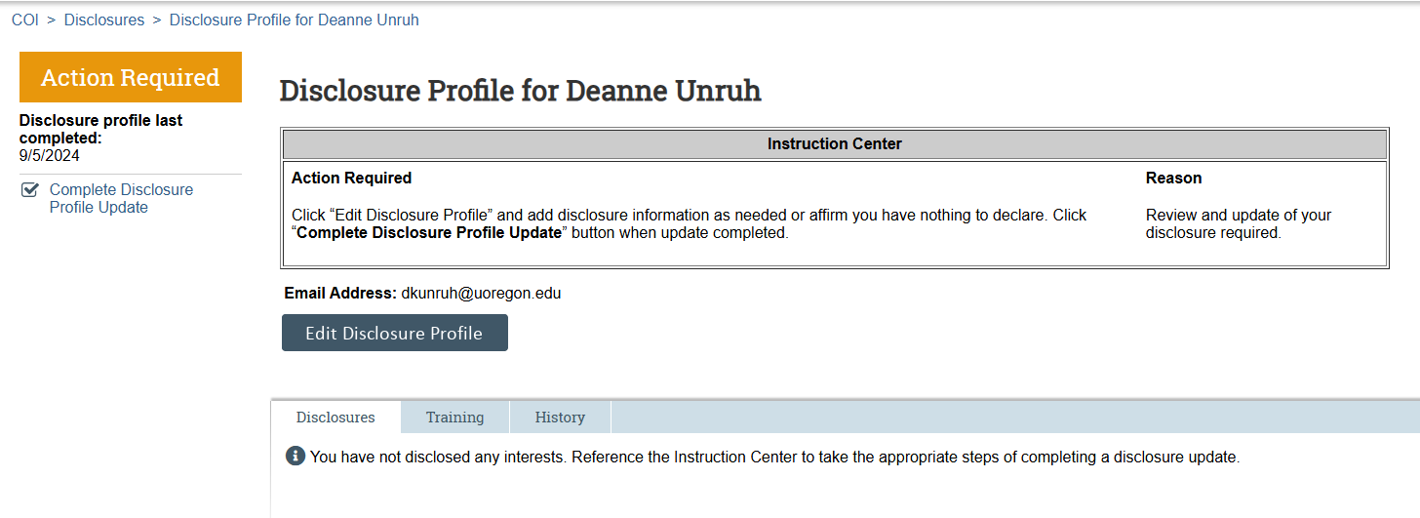
- Review the instructions and policies. If it’s the first time you’re submitting a disclosure, check the certification box and click “save” before continuing. If you’re updating an existing disclosure, the box may already be checked. Select “Continue” to proceed.
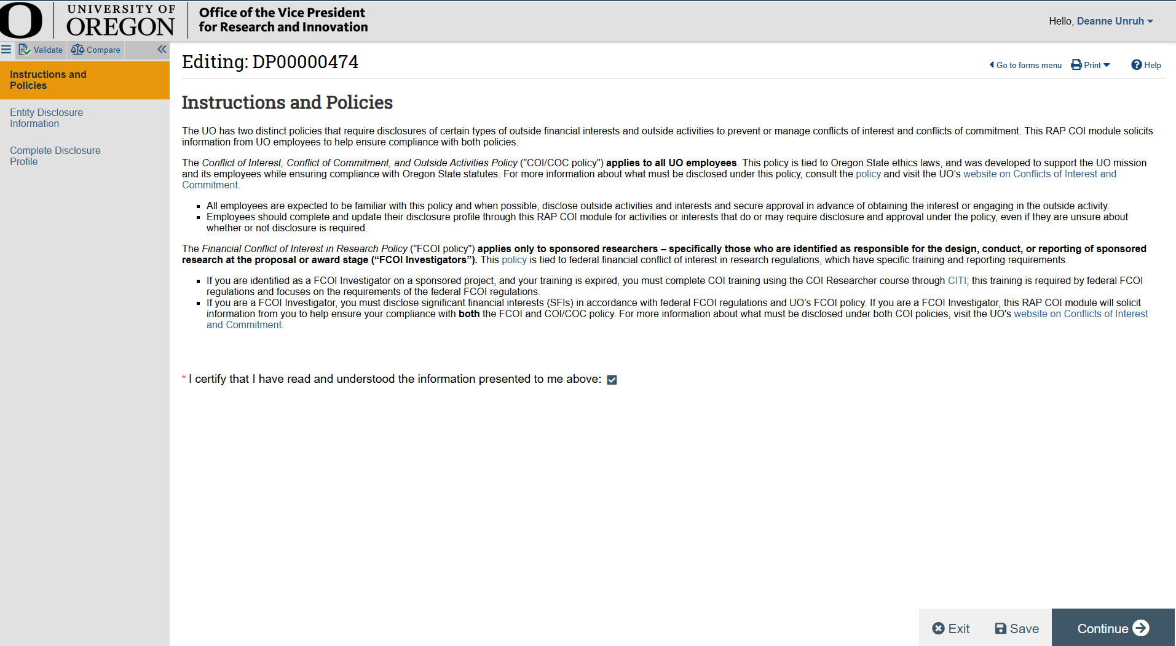

- Select “Yes” to add an activity or interest for you, your spouse, your dependent child, another relative, or household member to your disclosure. If you have no activity or interest to disclose, select “No,” then skip to step 9.
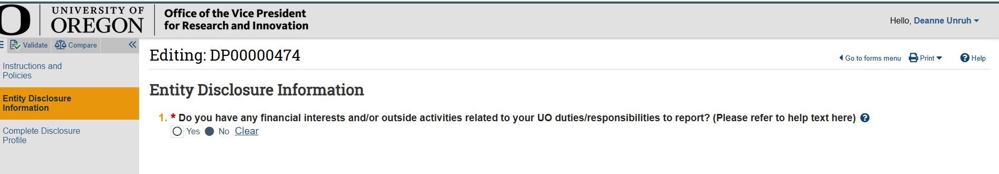
- If yes is selected, select the “+Add” button.
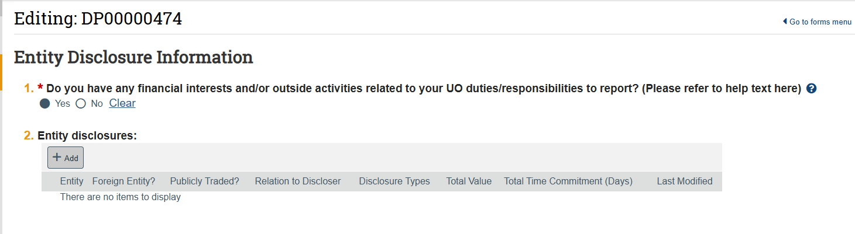
- A panel with additional questions will open on your screen. For question one, search for the entity. If you locate the entity, select it and move to question 2. If you cannot find the entity, select the ellipses (…) below the search bar and enter the entity information.
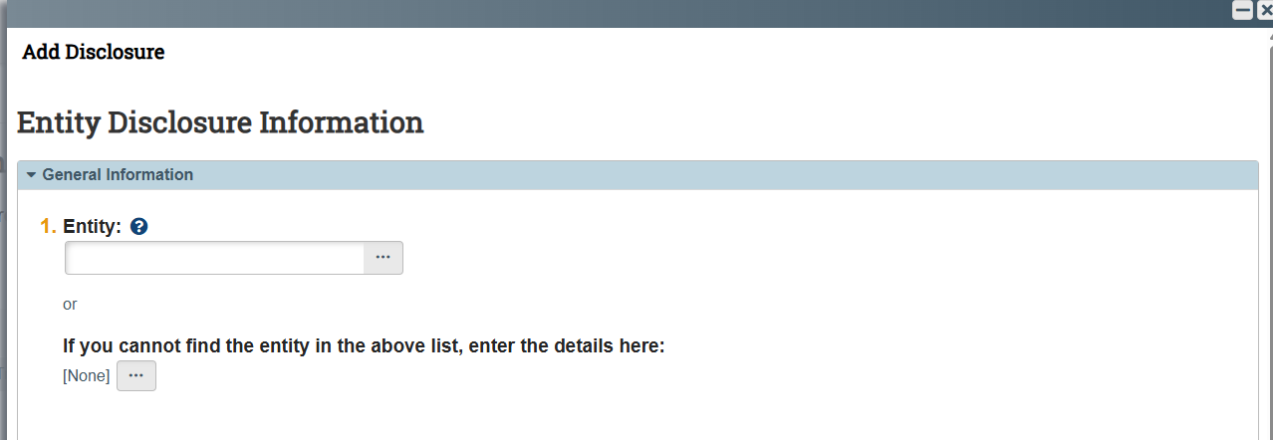

- Select the checkbox(es) to indicate whether this activity is associated with you, your spouse, or dependent child. If this activity or interest is related to a relative or household member, select “self” and move forward. There will be a text box later in this process where you can share additional information to clarify.
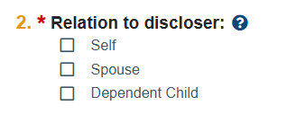

- Select each category that applies to your interest or activity. Each checkbox will display unique questions. Click “OK” when you’ve finished entering information.
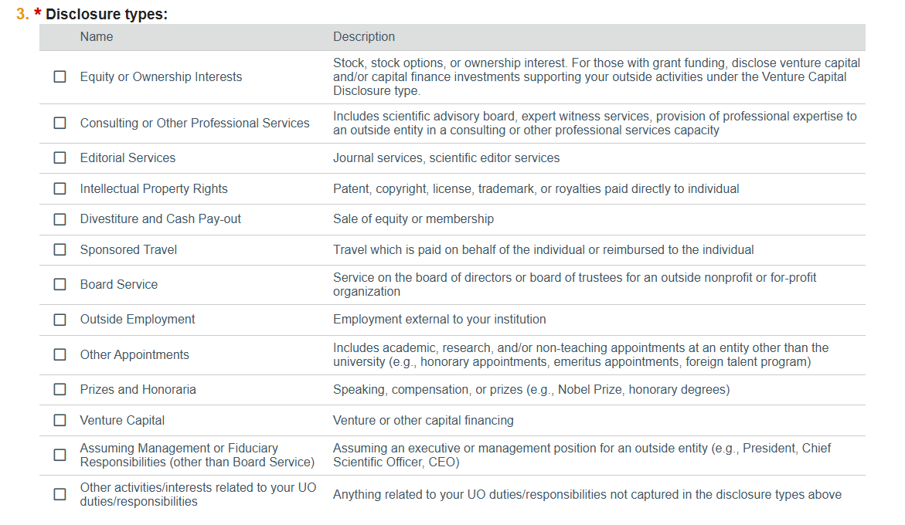
- Questions with a red asterisk are required, but users are encouraged to provide any additional context that may assist the Conflict of Interest Office in making their determination on whether a conflict of interest or commitment may exist. You may receive a request for additional information after the Conflict of Interest Office receives the disclosure. If you have any questions or concerns about the information being requested, contact coi@uoregon.edu.
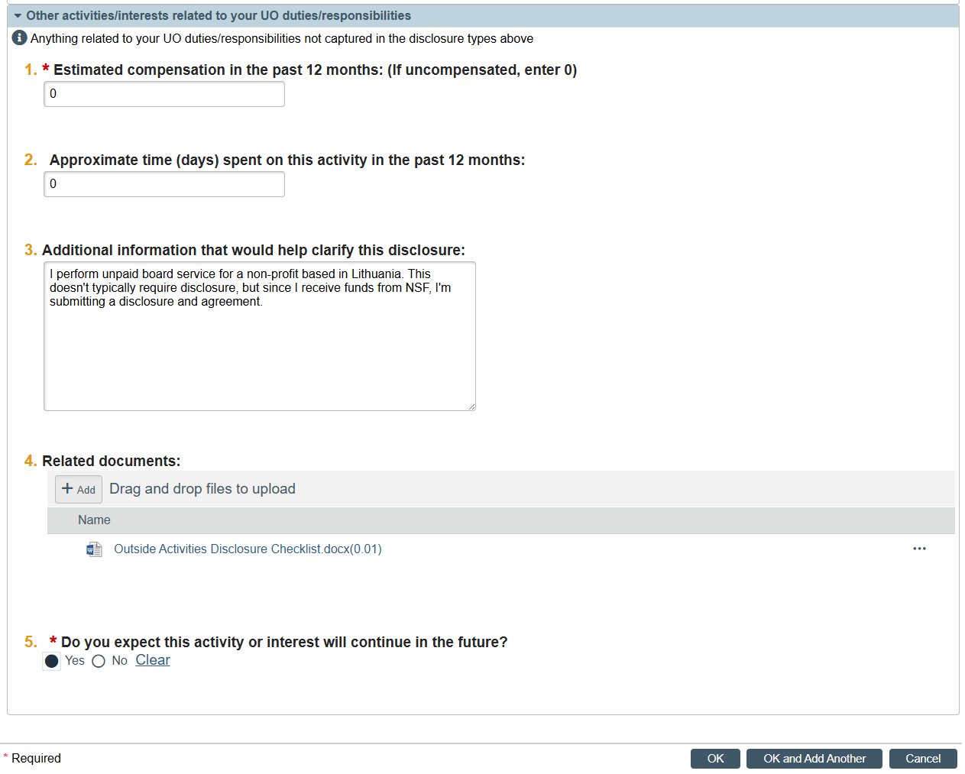
NEW: Effective October 10, 2025, if you receive funding from the National Science Foundation (NSF), the National Institutes of Health, or the U.S. Department of Agriculture (USDA) and you have added an activity or financial interest with a foreign entity that is included in your biographical sketch and/or current/pending support document, you must upload a copy of the agreement in the related documents question. NSF and USDA require the UO to review agreements with foreign entities to be sure they do not conflict with award terms and conditions and to retain copies of those agreements. NIH requires UO to retain a copy of the agreement and provide it upon request. Examples include, but are not limited to, courtesy appointment contracts or appointment emails, employment contracts, stock purchase agreements, shareholder agreements, and equity incentive plans.
- After you have entered all relevant information, select “OK,” and the panel will close.
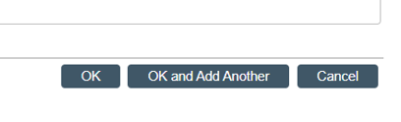
- You will see a summary of the disclosure appear. Select “Save”.
11a.) If you are done adding interests and/or activities, select “Continue”.
11b.) If you have additional interests to add, return to step 5 and repeat as necessary.
11c.) To remove an interest, select the “x” icon on the right side of the row you wish to delete. A warning will appear in your browser confirming you intended to delete the interest. Select “OK” to delete the interest.
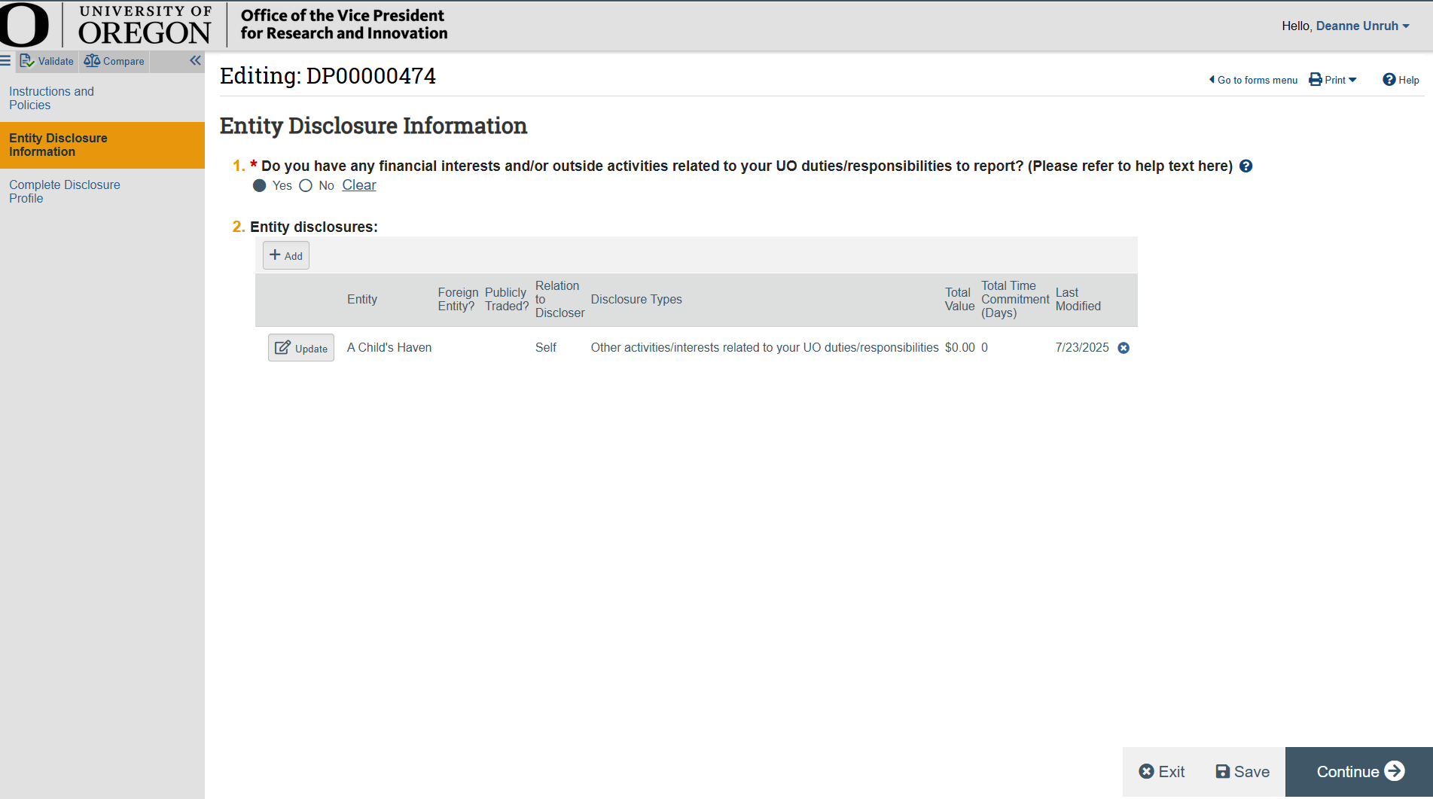
11c
11b
11a

- For Sponsored Researchers: There are 3 required questions under the section “Additional Information.” If you’re a sponsored researcher and do not see these questions, please contact the Conflict of Interest Office at coi@uoregon.edu.
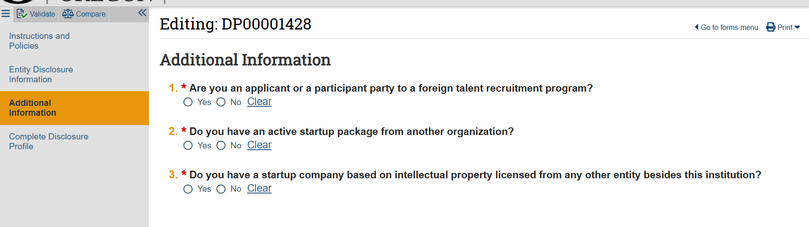
- Additional questions may appear in this section if you answer “Yes” to one or more of the above questions. When you’re done entering responses, select “Continue”
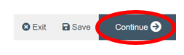
- To submit your disclosure profile, select “Submit Disclosure Profile” at the center of the screen. Selecting “exit” or “save” will allow you to come back to your work later, but it will not submit your disclosure to the Conflict of Interest Office.
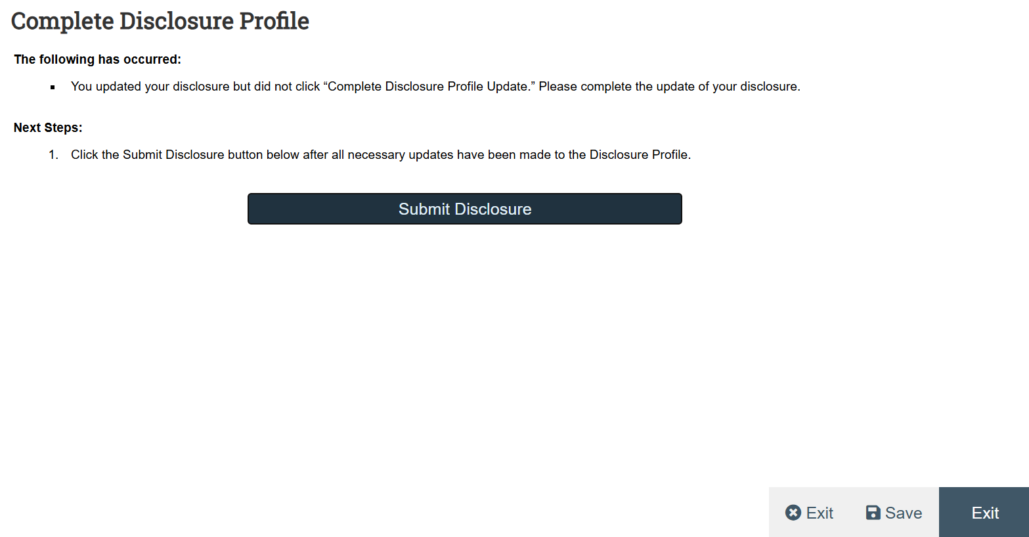
- A pop up window will appear. Review the affirmation and select “OK” to agree. If you’re unable to agree, please contact coi@uoregon.edu.
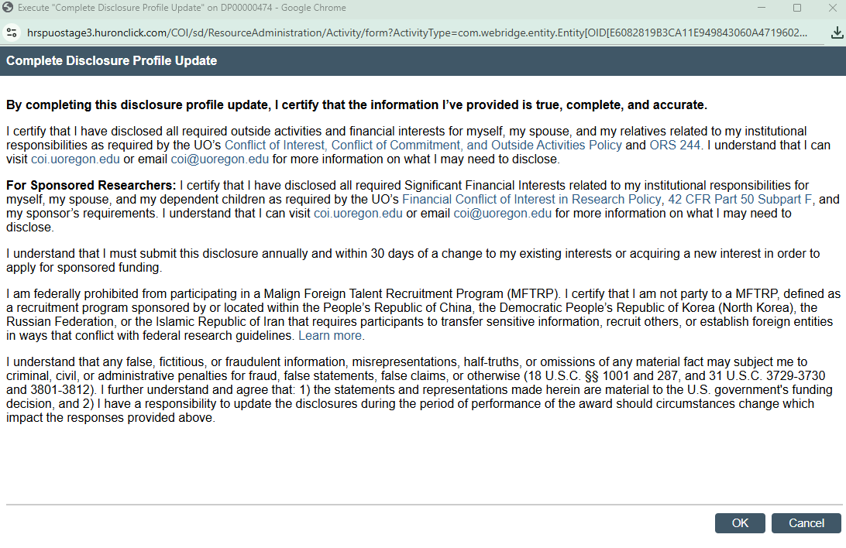
- Your profile will now display “No Action Required” and you will receive an email confirming that your profile was successfully submitted. Conflict of Interest staff will review your profile within 3 business days and request additional information if necessary.

Thank you for your attention to this important compliance requirement!

