Responding to Requests for Clarifications in
the Research Administration Portal
- After logging into the Research Administration Portal (RAP) Conflict of Interest (COI) module, select “Dashboard.” Then, in the “My Inbox” tab, click the Disclosure Profile that should be listed as “Action Required.” Click on your profile.
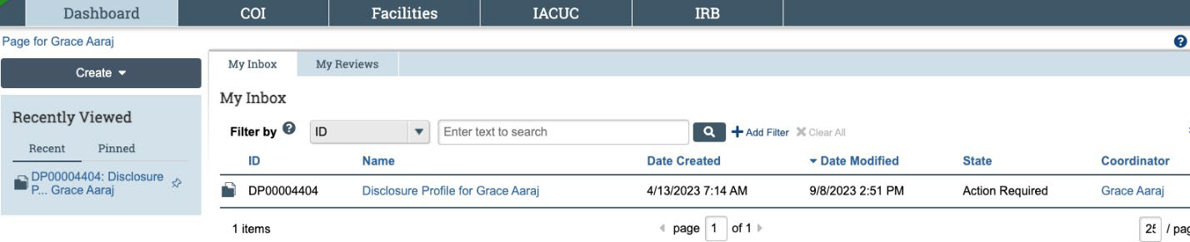
- You are now in the Disclosure Profile workspace. Click “Submit Response.” A pop-up window will appear.
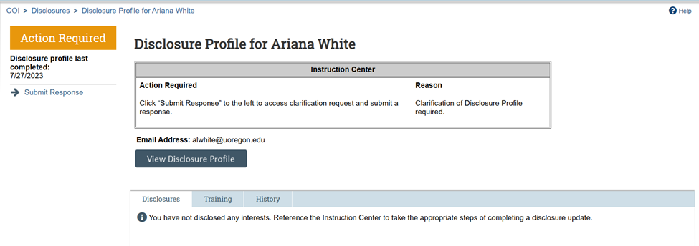
- The window will show the pending clarification request. Click “Update.”
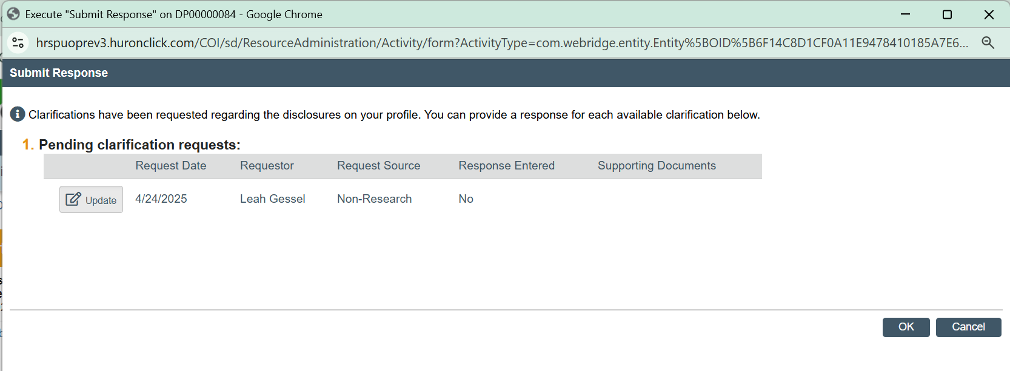

- From this window:
  - Reference the requested information under item 4.
  - Provide a response to the request in the box under item 6.
  - Optionally, you can add documents related to your response under item number 7.
  - Click “OK” on the bottom right when you’ve completed your response.
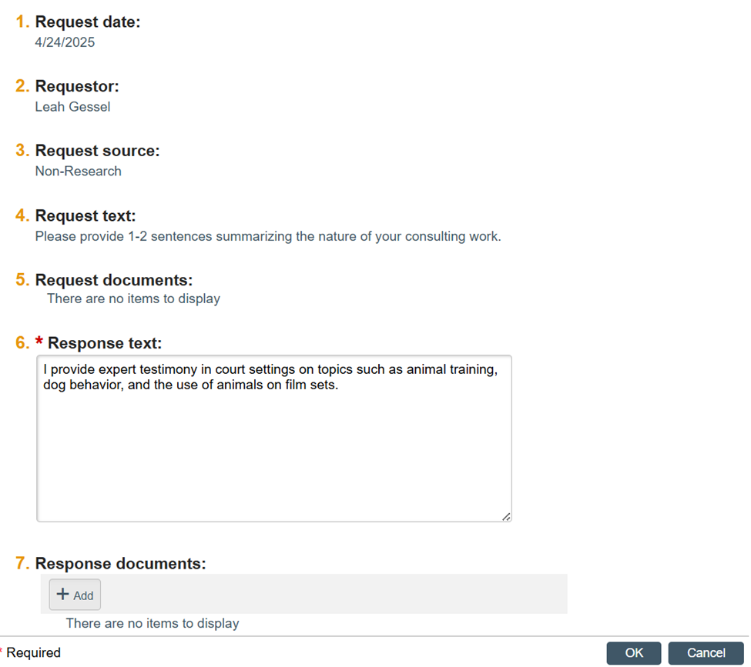
- The pane closes, and under “Response Entered,” it will now say “Yes.”
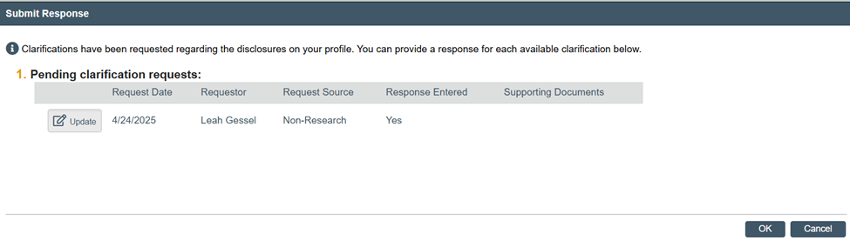
- Click “OK”. The response will be sent to the COI Administrator, who will proceed with reviewing your disclosure or request additional clarifications if needed.

