

TeACS Training Checklist

Minimum Training Required Prior to Animal Handling

Animal Occupational Health and Safety Program
- Log on to CITI and complete the course “University of Oregon Occupational Health and Safety for Working with Animals” (New to CITI?).
- Email the University Health Center from a “uoregon.edu” email account, include your name and 95#. They will provide a link to a protected medical form for completion. For additional information on this program, visit Animal Occupational Health and Safety Program Info.

Volunteers/unpaid Students Only
- Submit the “Volunteer Service Form” to:
  - IACUC@uoregon.edu and
  - RiskManagement@uoregon.edu

Additional Training in Order to Gain Facility Access

Regulatory Training
- Log on to CITI and complete the course “University of Oregon Introduction to Animal Research”.
- Visit the AWS website and review the policies, then complete the quiz.

Facility Specific Training
Contact TeACS for the following:
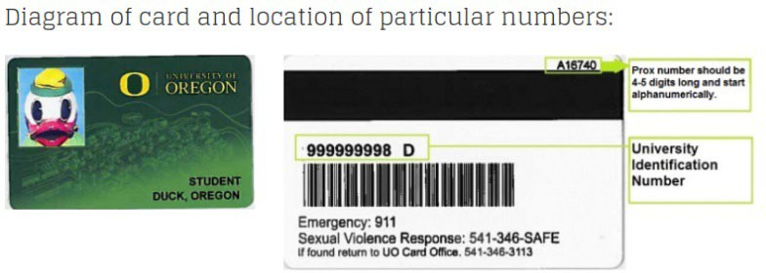
- Send access info:
  - Name
  - UO ID# (95#)
  - Proximity #
  - Requested 4-digit access PIN
  - Cell Phone Number
  - PI Lab
  - Role (e.g. undergrad, grad student, post doc, lab manager, etc.)
- TeACS policy training
- Facility tour and hands-on animal training
- Skills assessment

Additional Trainings

Surgery Training – Only as Requested by your Faculty Member
- Log on to CITI and complete the course “University of Oregon Introduction to Survival Surgery”.
- Contact the Attending Veterinarian, UO Veterinarian for:
  - Hands-on surgical training
  - Surgical assessment

Lab/Protocol-Specific Training
- Complete the RAP Access webform to request access to RAP.
  - Read the IACUC protocol(s) associated with your project(s) (How to view protocols in RAP).
- Contact your lab supervisor.

Other TeACS Trainings
Contact TeACS for the following:
- Food and Fluid Regulation – Required for anyone planning on working with animals that are having their food/fluid regulated
- Colony Management – Required for individuals that are planning on maintaining breeding colonies, weaning, or performing permanent identification techniques on their rodents
- Autoclave use training – Required prior to utilization of autoclaves
- CO2 Euthanasia Training – Required prior to utilizing the TeACS CO2 euthanasia stations
- Other technique trainings (e.g. injections, blood draws, organ harvest, oral gavage, cervical dislocation) performed at user request

