Accepting a Management Plan in the Research Administration Portal
- After logging into the Research Administration Portal (RAP) Conflict of Interest (COI) module, select “Dashboard.” Then, in the “My Inbox” tab, click the Disclosure Profile that should be listed as “Action Required.”

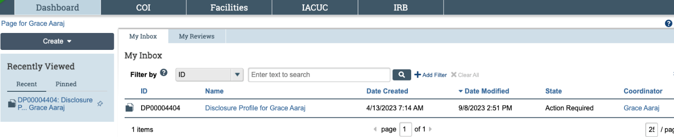

- You are now in the Disclosure Profile workspace. Select “Review and Accept Plans.” You are able view the plan by selecting the PDF of the management plan from this screen.

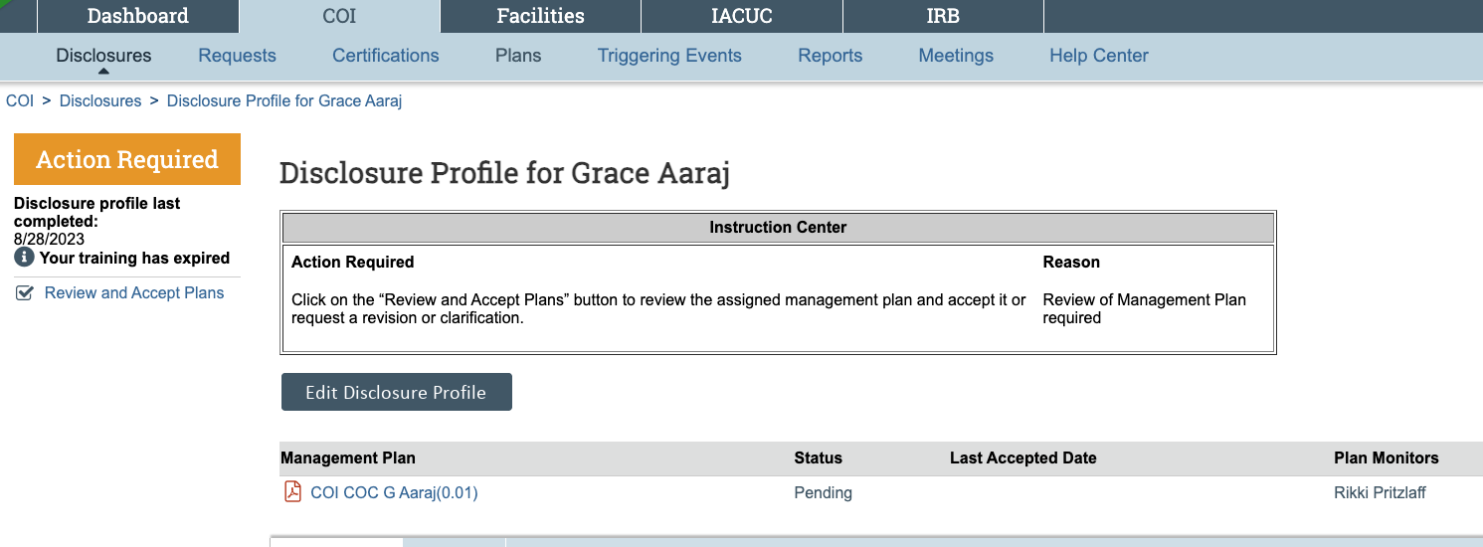

- Select “Update” to review and accept the plan.

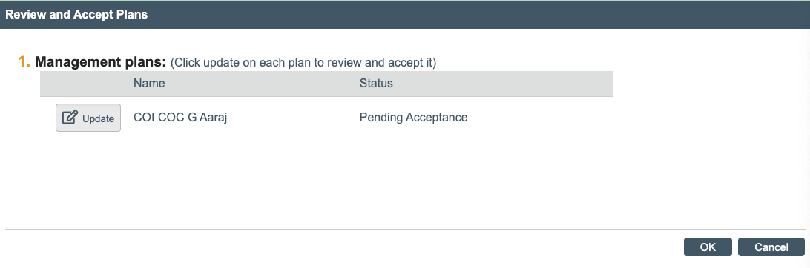
- From this screen, you can view the plan by selecting the PDF document in item 1. Item 2 will show whether this plan covers any sponsored projects. Item 4 contains comments regarding the acceptance of your plan and applicable policies your plan is subject to.

If you are ready to accept this plan, select “Yes.” If you are not ready to select the plan, click “Cancel” and email coi@uoregon.edu.

Once you select “Yes,” you may add comments to your acceptance. Please do not add any comments regarding changing or revising the plan. If you want to make change or revisions to the plan, do not accept the plan and instead email coi@uoregon.edu

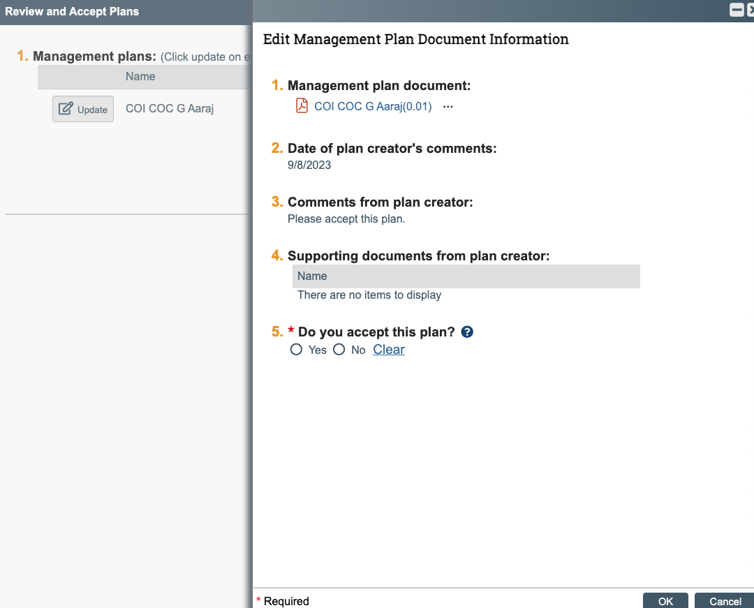

- Once you accept the plan, the screen below will come up. The plan should now be listed as “Accepted.” Click “Ok” to exit out of this screen. Clicking cancel will leave your profile in an “Action Required” state, which can prevent future grant awards from proceeding if you are a sponsored researcher.
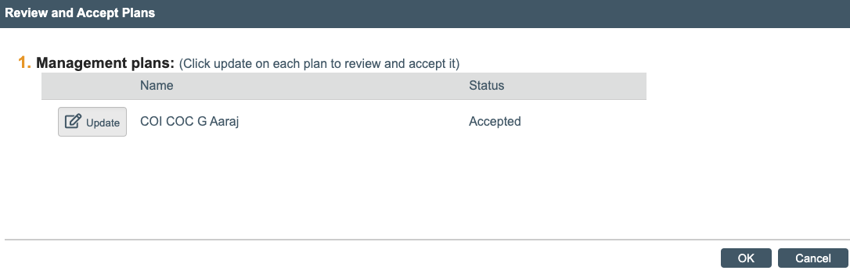

- Once your profile is back to the “No Action Required” state, no further action is needed.

