Completing an Ancillary Review in the Research Administration Portal
- Log in to the Research Administration Portal (RAP) Conflict of Interest (COI) module and go to your Dashboard. From your Dashboard, select the plan that needs your review by clicking on the name of the plan under the Name column.

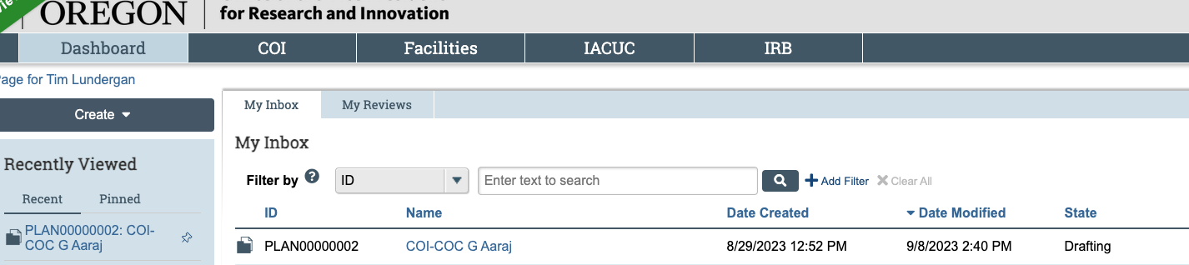

- You are now in the plan workspace. Please note that although the screen states that the plan is in the draft phase, the plan reflects the version finalized in prior email communications. You can select “View Management Plan.” When ready, click “Submit Ancillary Review” to add your formal approval to the plan. If you have additional requests for revisions, do not submit your ancillary review and contact coi@uoregon.edu.

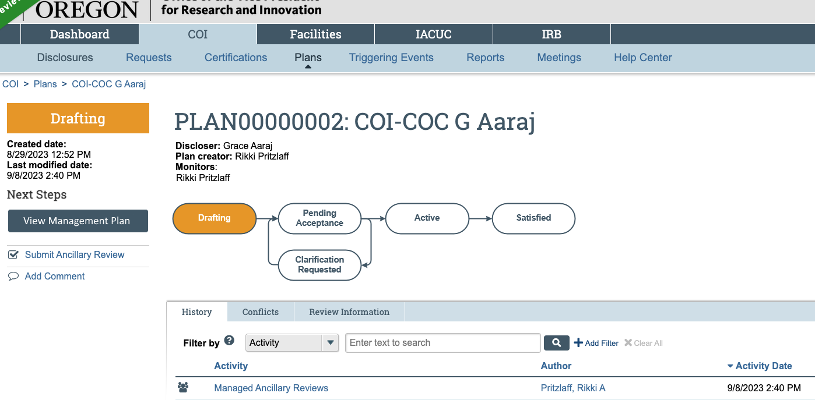

- After you click “Submit Ancillary Review,” you will see the screen below. For the first question in this screen, you will always check the box. There should only be one review listed.
The answer for question 2 should always be “Yes.” If you feel as though you cannot approve the plan, do not complete the ancillary review and contact coi@uoregon.edu.

You can add any comments you would like for question 3 and any supporting documents feel may be helpful for question 4. Most reviewers leave these two questions blank.

When you are ready to submit the ancillary review, click “OK.”

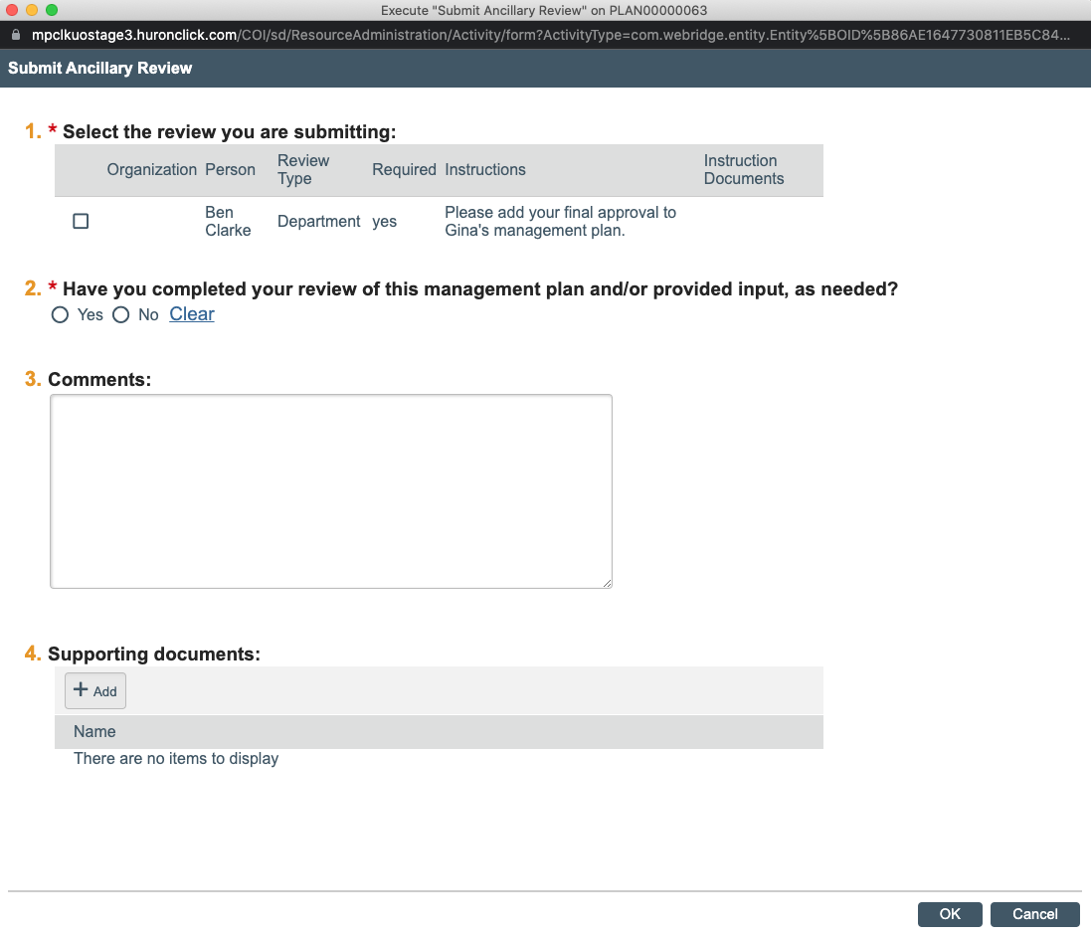

- Once you have submitted your ancillary review, you will see a notation in the history tab of the plan workspace. When all required ancillary reviews have been submitted, the discloser will be sent notice to accept the plan, and the plan will be active.

