How to Add the Export Compliance Course in CITI

- Log in to your CITI account (link prompts you to enter your Duck ID) and select “My Courses” for your University of Oregon affiliation. Once in that tab, select, “View Courses.”
Note: you may get a screen between steps 1 and 2 asking you to update your information. If so, complete that update to move to step 2.

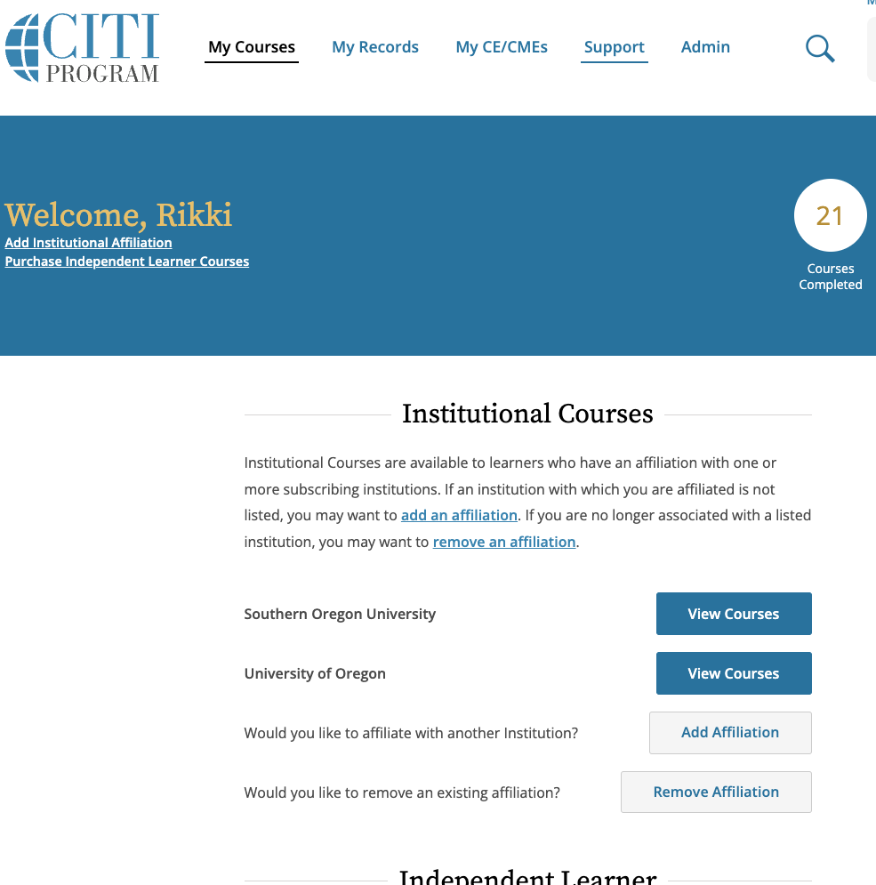

- Once in the “View Courses” screen, scroll to the bottom to access the “Learner Tools for University of Oregon” menu and select “Add a Course.”

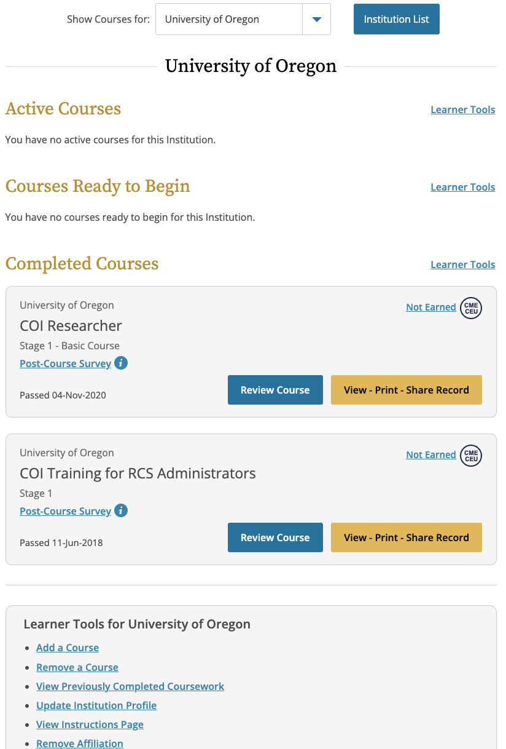

- This will take you to the “Select Curriculum” page. Check “Export Compliance” and select “Next.”

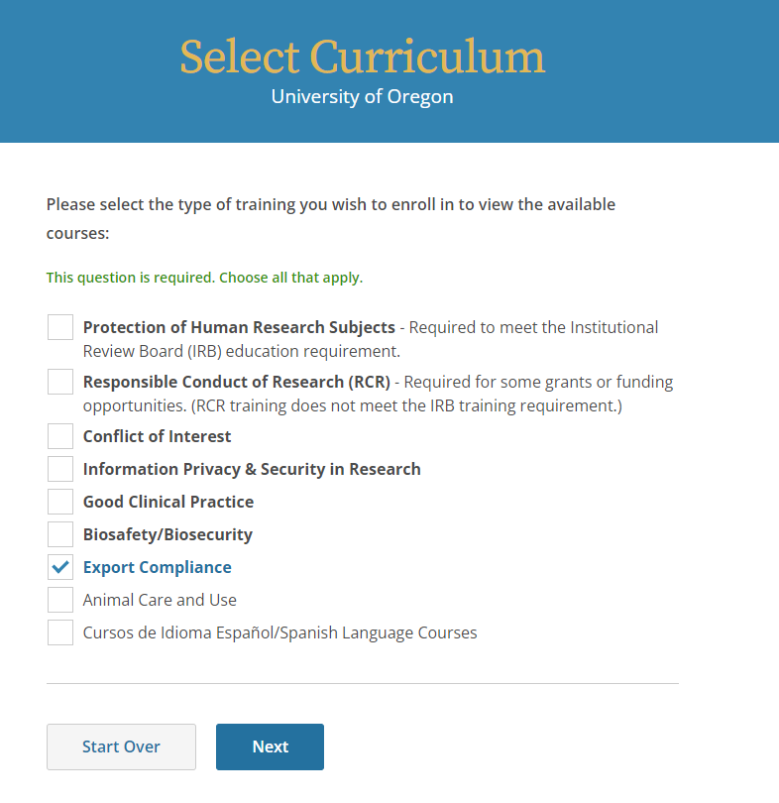

- You have now added the Export Compliance course to your “My Courses” page and can complete the course.

