Budgeting adjusted salaries on sponsored projects: minimizing the financial impact of UO’s OPE Rates on sponsored awards.

OVPRI recognizes that UO’s Other Personnel Expenses (OPE) rate can limit the amount of effort (FTE) that researchers can budget on sponsor projects. OVPRI’s Sponsored Projects Services is happy to announce a change to budgeting recommendations that allows researchers to either continue to budget full salaries or to choose the new option, budgeting using “adjusted salary” figures. This budgeting method reflects the process that Budget and Resource Planning (BRP) uses on non-sponsored funds.

The BRP process allows units to reduce salaries by the average leave adjustable rate
and then apply the current OPE rate, which essentially allows them to budget at a “reduced” OPE rate. See this link for guidance: https://brp.uoregon.edu/content/Calculation-Guidance.

Please note that the rate applied is the federally approved OPE rate, as indicated on UO’s F&A rate Agreement, but the direct cost charged to the award is lessened because of the adjusted salary amount.

Effective December 1st, your unit/PI may choose to budget any lab personnel, regardless of classification type (i.e. NTTF, TTF, OA, etc.), with reduced salaries. However, please note that units will be financially responsible for any salary overage on a sponsored award, whether it is a consequence of this budgeting method or any other reason. See below for more information.

You are not required to budget with the adjusted salary. SPS recommends that you do not budget with this method unless you are certain that personnel on the sponsored award will take their expected leave during the year.

If you select the adjusted salary budgeting method, SPS will implement the below. If you budget without the adjusted salary, the below will not apply.

- Document update: The SPS Quick reference card language will be updated to the following (changes in bold):
  - Researchers may budget salary and OPE at 100% effort if your staff do not take at least the average leave. If you, as the PI, are confident that everyone so budgeted will take at least average leave, then the effort can be calculated at the reduced salary and OPE. Please note that the unit that will receive ICC associated with this proposal will be required to cover the full budget shortage, whether resulting from reduced salary or other any other reason. Please work with your pre-award SPA when you are developing your budget.

- EPCS process changes: The DGA/PI will be required to click a button in the budget tab of EPCS which indicates if the PI is budgeting with the reduced OPE rate. See below:

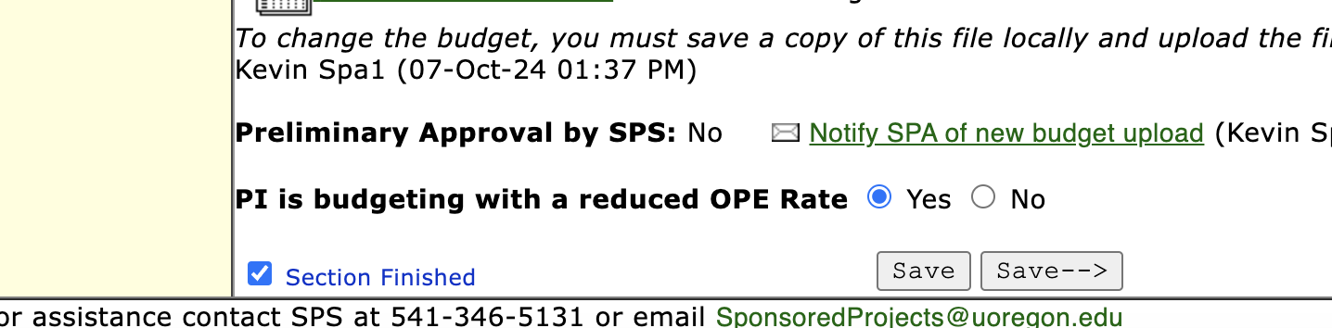
- This button will be a required field. Further, when the DGA/PI uploads a budget, a pop-up will open that reminds the DGA to answer the question. If a revised budget is uploaded over the old one, it clears out the field so that it must be answered again (with a pop-up reminder).

- If “yes” is selected for the “reduced OPE rate” button, the following will happen:
  - SPS will be alerted, and the pre-award SPA will ensure the department has budgeted according to the BRP guidance.
  - The EPCS approval email to the PI asking them to finalize the record will require the PI to certify that they recognize the risk of budgeting with this method. See the yellow text box below: 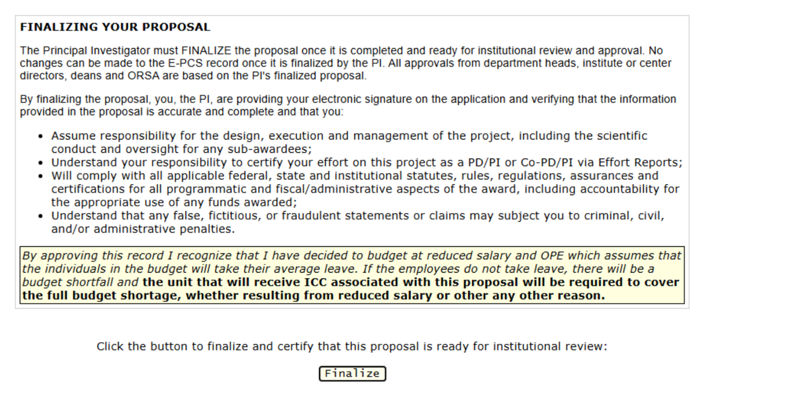
  - Once the record is finalized, the Director/Head or Dean will also be alerted to the reduced OPE budgeting and the risk. Their approval notification in EPCS will look like this:
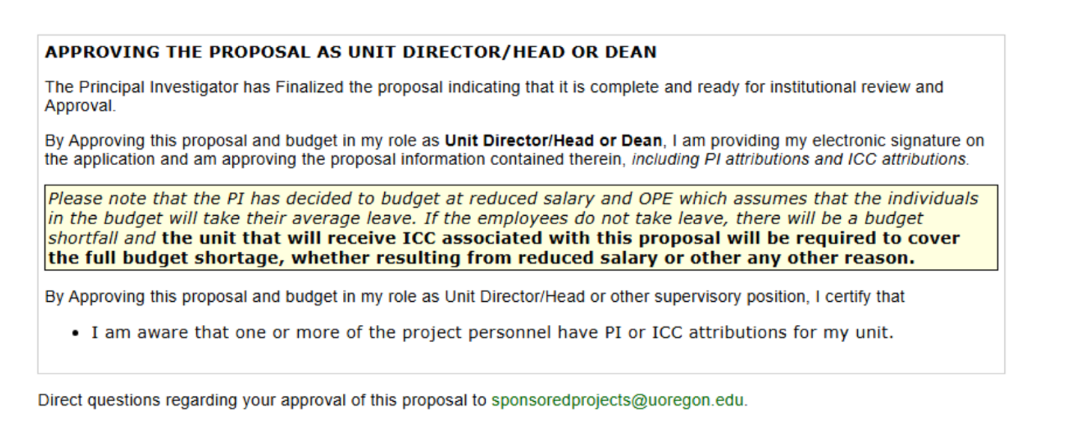

Example of Impact:

Assume you have a 12-month faculty member on a grant who has a base salary of $70,000. With the previous method of budgeting, the grant would include the full salary ($70K) plus a blended OPE rate of 75% ($52,500) for a total budgeted salary plus OPE of $122,500 and an apparent benefits rate of 75%.

To budget with adjusted salary, their salary costs would be reduced by 11.30 percent – so salary would be budgeted at $62,090 and the 75% blended OPE rate would be applied to the adjusted salary resulting in a budget of $46,568 for benefits and a total salary and OPE budget of $108,656. This reduces the proposed budget by $13,843 and results in an effective benefits rate of 55.2%, and more money can go toward direct costs toward the grant.

