Environmental Issues Committee Meeting Minutes
November 13, 2015, 12:00 pm to 1:00 pm
Columbia, Room 249
MEMBERS PRESENT
Faculty and Staff:
Erin Moore—Architecture
Shabnam Akhtari—Math
Brian Gillis—Art
Holly Lynn—Biology
Melynn Bates—American English Institute
Marie Swarringim—Campus Planning, Design, and Construction

Ex-Officio:
Eric Beeler—Student Sustainability Coalition
Steve Mital—Office of Sustainability
Christine Thompson—Campus Planning, Design, and Construction
Doug Brooke—Environmental Health and Safety

Other Attendees:
Sonya Carlson—Office of Sustainability
Kelsey Moore—Bike Loan Program
Gwen Bolden—Parking and Transportation
WELCOME AND UPDATES
Everyone introduced himself or herself. Steve then reported that he renewed the Association for the Advancement of Sustainability in Higher Education (AASHE) membership, based on the feedback received from the EIC members at the previous meeting. He also submitted a notice to AASHE letting them know that the services received are not quite meeting needs or expectations. He said that he received a long response back from AASHE stating that they are taking action at the board level to address concerns. He didn’t think that the board intentions were solely in response to his letter but rather reflected the fact that a number of institutions have the same grievances. Eric Beeler noted that the AASHE conference, he attended this year was the best out of the four he has attended and thought that the new leadership played a role in that success.

Steve gave an update on the Internal Carbon Tax proposal. Over the summer, he met with Vice President Jaime Moffitt to discuss the recommendation put forth by the EIC on the Internal Carbon Tax Proposal. She requested more information on how the money raised would be spent, the energy savings, etc. The Office of Sustainability had tried to obtain this data, but faced resource constraints pending further indication that there was interest from the administration. With Vice President Moffitt’s request, Steve contacted George Hecht and had a meeting with staff which they outlined would result in a report sometime in January and could then be reviewed by the EIC in February and could be back to Vice President Moffitt around Spring Break.

REVIEW AND VOTE ON POLICIES
The Oregon Administrative Rules (OARs) are under review now that the UO is no longer governed by the Oregon University System and now has its own independent board. As such, a number of policies are being reviewed, updated and incorporated into the UOs own governing documents. The EIC has been requested to review and three recommendations were put forth for consideration. First, Steve reviewed these documents and annotated some suggested changes in the Comprehensive Environmental Policy (See Appendix 1). The first change reflected the fact that the old mission statement was referenced, so Steve found the updated mission statement and replaced that in the text. The next change was the addition of “sub-“ before the word “policy” underneath the Guiding Principal for Purchasing. This change reflects the fact that the university is trying to differentiate between policies that go on file and need to be reviewed by legal council and all procedural or sub-policies, which don’t need as extensive of a review. Brian moved to accept the changes as recommended. Holly seconded the motion. The committee voted unanimously to accept changes noted in Appendix 1.

Next, Steve recommended that the Recycled Paper Policy (APPENDIX 2) be repealed from the policy library and be moved as is to a sub-policy under the Comprehensive Environmental Policy. Steve reiterated that he was not recommending changing the policy, just move it to a new location. Brian moved to repeal the policy from the policy library and move it underneath the Purchasing guideline of the Comprehensive Environmental Policy. Holly seconded the motion. The attending committee voted unanimously in support.

Finally, the UO inherited the Oregon University System’s Sustainability Policy (See Appendix 3), which Steve made the following recommendations:
- Split into academic and administrative policies
- Item #5 is an administrative policy and is covered by CEP. It is duplicative with the Guiding Principles outlined in the Comprehensive Environmental Policy and can be repealed
- Items #1-4, and 6 are academic and should be referred to the UO Senate, as the charge of the EIC does not cover academic concerns

Holly moved to repeal Item #5. Christine seconded the motion. The committee unanimously passed the motion. The committee did not need to vote to split the into academic policies, but expressed

PRESENTATION: TRANSPORTATION
The committee received reports on the following topics:
- Policy and monitoring (Christine Thompson, Campus Planning, Design, and Construction)
- Programs (Gwen Bolden, Director Parking and Transportation)
- Bike Loan Program (Kelsey Moore, Bike program coordinator)
Erin adjourned the meeting at 1:00.

APPENDIX 1
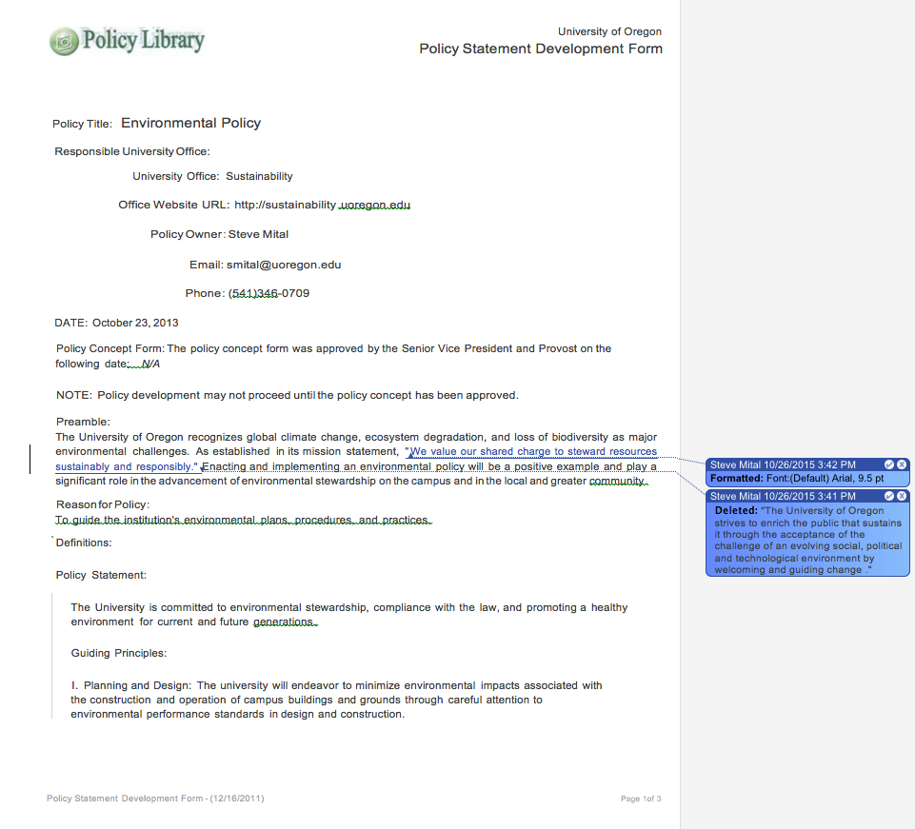

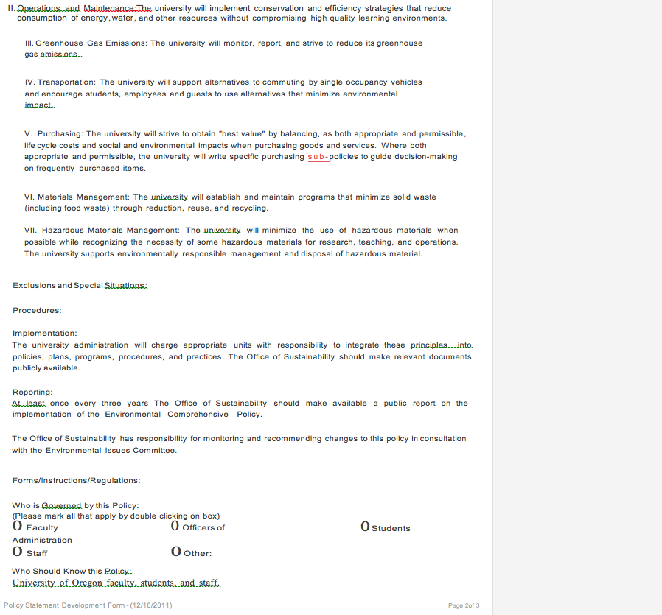
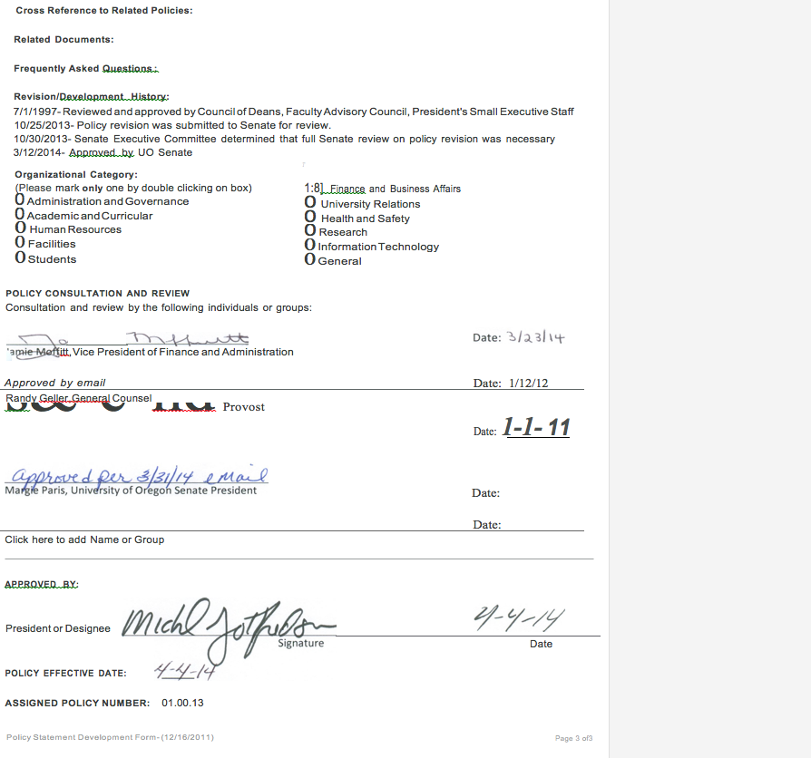

APPENDIX 2
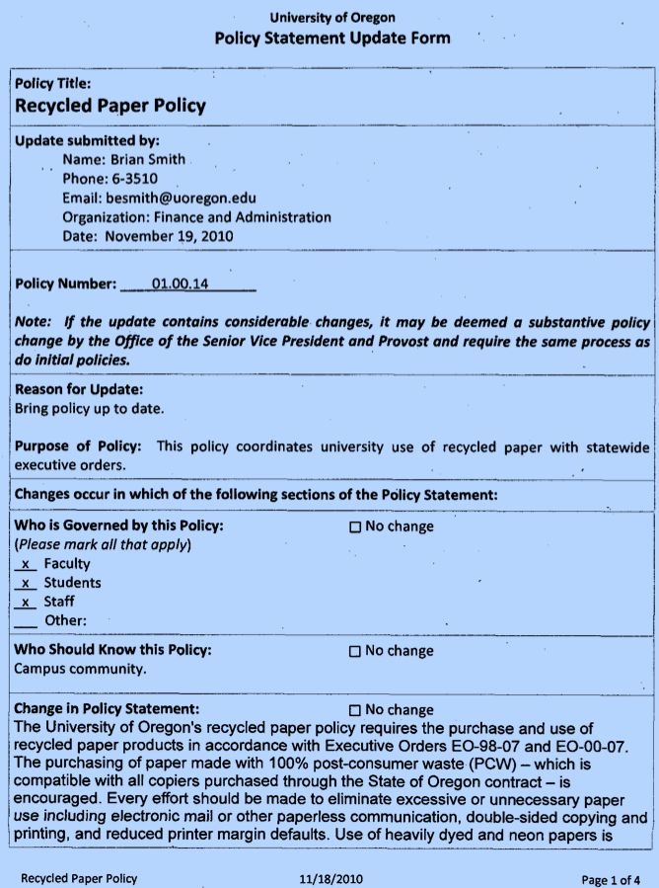
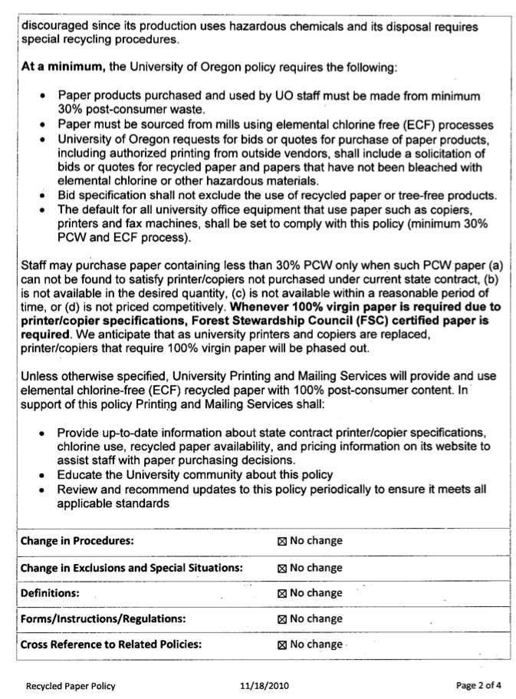
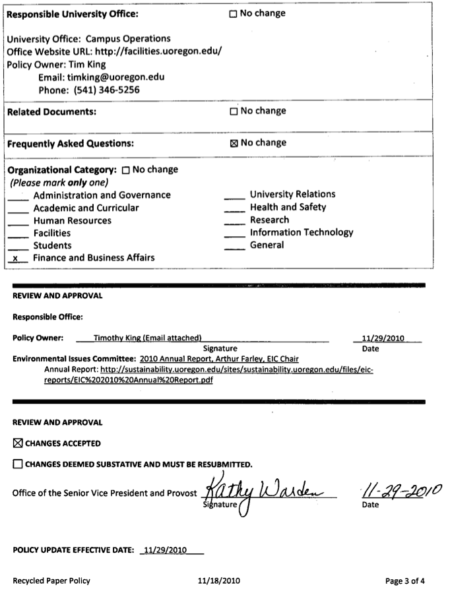
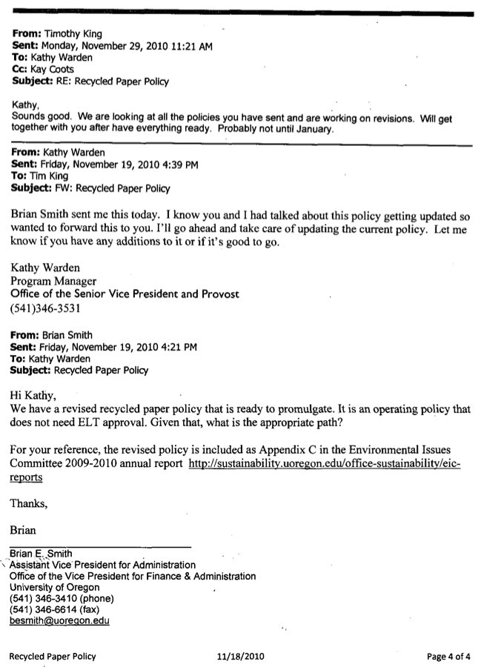
APPENDIX 3
