Instructions for Instructors

How to Create a Date Range/ Grace Period for Exams
Sometimes instructors would like students to be able to take exams within a specific date range. For example, an instructor may want to allow students to take their exam any time between the date range of 7/21- 7/25. In AEC Connect, this can be set up using the Grace Period Feature.

- Log in to AEC Connect with your DuckID and password. This will take you to your Dashboard.
- Click “Continue to View Student Accommodations”.
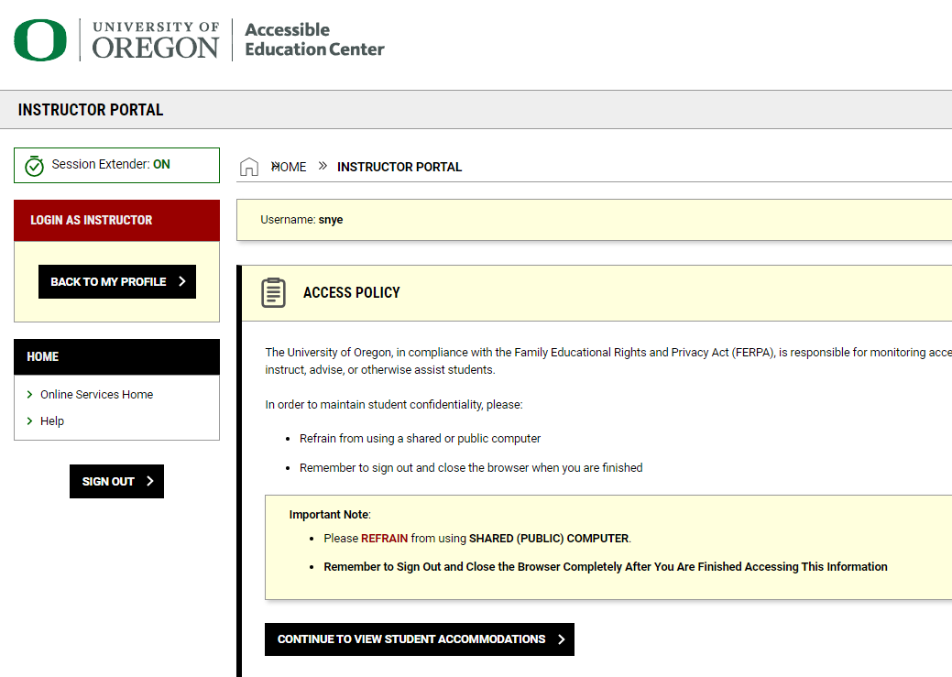
- Next, click “Alternative Testing” on the left side of the screen.
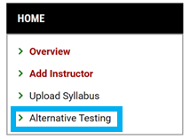
- Click “Testing Agreement” at the top right of the screen.
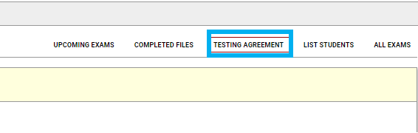
- Find the course you would like to add an exam to and click “View/ Modify Testing Agreement”.
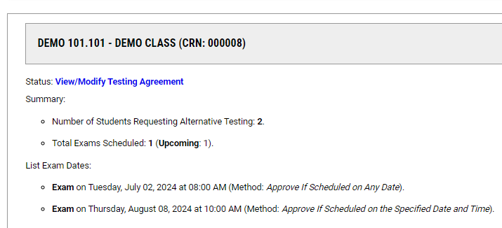
- Click “List Exam Dates” at the top of the screen.
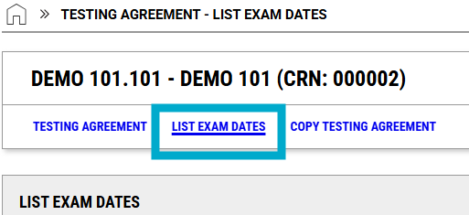
- Scroll to the box that says, “Exam Detail” to add a new exam.
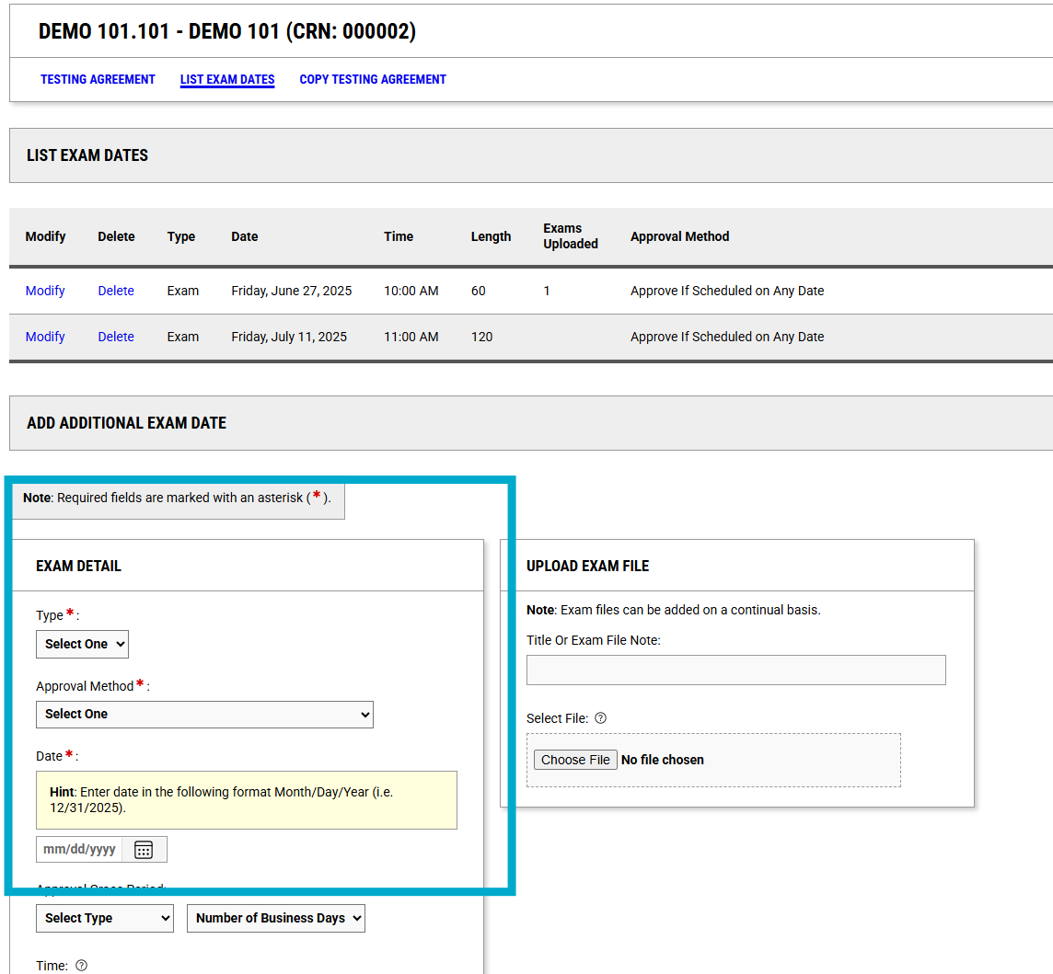
- Enter the exam type and approval method.
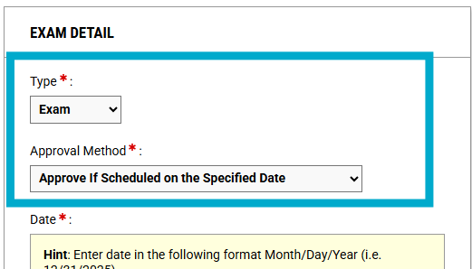

- Next, create the Date Range/ Grace Period:
  - Select a Date
  - Under “Approval Grace Period”: select “Before”, “After”, or “Before and After”.
  - Under “Number of Business Days”: select the correct number of days.
    - Example: If I want students to be able to schedule their exam within the Date Range of 7/21- 7/25, I would enter the Date as: 7/21/2025, the Approval Grace Period as: After, and Number of Business Days as: 4 Business Days
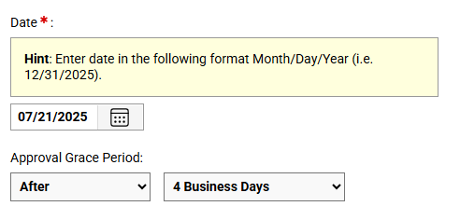
- If you would like students to take the exam at a specific time, please select the time. If not, you can leave this blank.
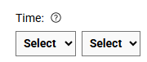
- Add the Standard Length of Exam (in Minutes) and Click “Save Exam Date”.
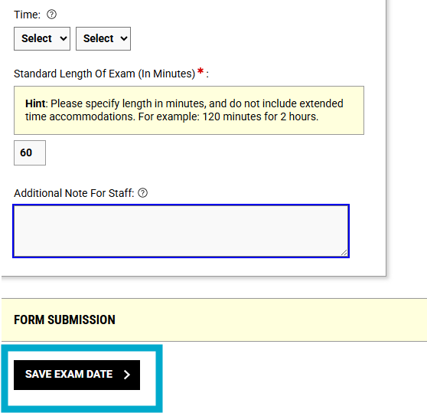
- You will be able to view your exam under "List Exam Dates".
  - Keep in mind: Students will be able to see the date range when scheduling their exams.

