LinguaFolio® Jr. Teacher’s Guide
Grades K-2: Laying the Foundation for Success
Grades 3-5: Transitioning to LinguaFolio®

For all of us with access to younger school-aged children, this is a common experience: My five year old daughter gets buckled into her car seat and immediately asks, “Where are we going?” It is like clock-work. She desires to know what is going on; she wants an expectation of what is to come. Soon thereafter, “Why?” never fails, right? While she may not be old enough to fully understand the answer, she inquires about the purpose of our ride and, with increasing frequency, vague responses do not suffice. Next, of course, “Are we there yet?” With aggravating persistence, she needs to know if we have reached our destination; have we met our goal?
Our young learners are very capable of understanding the answers to these questions, not only in the car, but also in our classrooms. Where are we going? What are we learning? Why? What is the purpose of this unit / lesson / task? Are we there yet? – Have we met our learning goal? The purpose of the LinguaFolio® (LF®) is to foster learners’ ability to answer these questions themselves and to become more autonomous learners. However, this is a gradual process which we scaffold for our learners. Our goal in this LF® Jr. Teacher’s Guide is to lay the foundation for success and to help transition learners to being able to use LinguaFolio® more autonomously.

Please note: You can access the STARTALK learning materials referenced in this guide here: https://lfonetwork.uoregon.edu/linguafolio-jr/resources-2/. These materials include PDF files of the classroom poster, as well as handouts for students, including the biography, passport, and dossier.
Step 1: Create the Plan
Where are we going? While this question can be answered from three different perspectives (the unit, the lesson, and the task), it is essential to remember that these three perspectives are intricately related. Like the traditional Russian babushka dolls, the tasks nestle directly into the lessons which nestle directly into the unit. It is not the purpose of LF® to mandate specific classroom tasks to teachers, or to dictate lesson plans. Each teacher must play to his or her strengths and also consider learners’ strengths and weaknesses. There is more than one way to arrive at our learning objective. One of the tenets of the LF® is, however, informing our learners what those learning objectives are.
Before we can adequately answer our learners’ questions, we have to first decide for ourselves. To facilitate this, it helps to have an outline of how the unit’s learning objectives relate to the lesson plans and the tasks that comprise the unit. Appendix 1 shows an outline template that could be used and illustrates an example that will be used throughout this teacher’s guide.

After deciding on the unit’s theme, the next thing to do is to identify the objectives of the unit. Starting with the learning objectives in mind commonly referred to as “backward design”. These objectives are taken directly from the LF®’s Can-Do statements which the National Council of State Supervisors for Languages (NCSSFL) created. The Can-Do statements describe what is expected of language learners across the range of language proficiency.

Furthermore, the Can-Do statements are divided into three modes of communication (interpersonal, interpretive, and presentational). Interpersonal tasks require the active exchange of information between the learner and the interlocutor (e.g., I can answer questions about my preferences using one or more words or memorized phrases). Interpretive tasks do not require that the learner actively produce the target language, but that he or she understand, or can interpret, others (e.g., I can understand some simple questions on familiar topics). Presentational tasks involve learners in actively producing the target language, but do not require an exchange of information (e.g., I can say the names of familiar people, places, and objects in pictures and posters using simple words or memorized phrases).
The explicit purpose of Can-Do statements is to elicit learner reflection: Can I …? Fostering accurate self-assessment of ability is one of the core principles encouraging autonomous learning. However, as NCSSFL created the Can-Do’s for each level of language proficiency (from Novice Low to Superior), they are meant to encompass large areas of language ability. Especially for younger learners, the Can-Do’s may be too vague for learners to accurately self-assess (e.g., I can answer questions about my preferences using simple words or memorized phrases on familiar topics), or too broad to be accurately self-assessed (e.g., I can say the names of familiar people, places, and objects in pictures and posters using simple words or memorized phrases).
The second step in creating the outline of the unit is personalizing these Can-Do statements with more concrete Can-Do statements that specifically relate to the teaching objectives. “I can say the names of familiar people, places, etc.,” becomes something like “I can identify pictures of Russian foods”. Critical to the LF®, these personalized Can-Do statements must be directly linked to something that can be evidenced as learner products included in the Dossier. A good question to ask oneself when creating these personalized Can-Do statements is, “How will I measure this?”

This question can be more difficult to answer when considering the Can-Do statements that relate to interculturality, or intercultural awareness (e.g., I can introduce myself in a culturally appropriate manner). Just as language ability emerges over time, so does understanding that culture has an impact on language use. The reality is that the two are very much intertwined. As such, teaching interculturality to young learners is not much different than teaching the language itself. When teaching language, we do not engage in an in-depth conversation on the differences between English grammar and that of the target language any more than we stress the differences between American culture and that of the target culture. In section 3, we will focus more on strategies for teaching interculturality, but how do we measure it? How do we evidence intercultural knowledge? With more abstract concepts, both of language and culture, it is sometimes best to record learners demonstrating their ability. In the example of introducing oneself in a culturally appropriate manner, a picture or an actual video or audio recording is a great way to accomplish this.

When deciding on the evidence, it is important to allow for some degree of learner personalization of the Can-Do statement. The purpose is to allow learners the freedom to choose how to apply their emerging language ability. These are the beginnings of the goal-driven behavior we wish to foster. In our example, the evidence for our second Can-Do statement allows learners to choose three of the ten Russian foods they have learned themselves. The learners then complete the task of surveying their peers and filling in their graph according to the teacher’s instructions.

Can you see the babushka dolls? When designing the unit, we choose our topic and select the NCSSFL Can-Do statements that apply to the unit. Next, we personalize the Can-Do statements. While choosing tasks that illustrate the personalized Can-Do statements, we deliberately allow for learners to further personalize the Can-Do statements by giving them power to choose how they will accomplish the task. Remember, with young learners, we are not talking about large decisions. We determine the task, but allow learners to choose some of the details. This ability to choose empowers and engages learners in the learning process, a core principle of learner-centered classes.

Best practices mandate having a clear vision of where you are going. LinguaFolio® facilitates this by providing clear end goals related to NCSSFL’s Can-Do statements. However, this important first step has not begun to answer our learners’ questions. Informing learners of our objectives is the next vital step toward LF®’s goal of enabling learners. Giving learners an explicit expectation of what they will learn focuses learner attention. Furthermore, LF® seeks to foster learner capacity to reflect on finished products and self-assess their ability. In step 2, we will explore two great options to accomplish these goals with younger learners.

Step 2: Create the LF® Enhancement

The purpose of the LinguaFolio® is to foster autonomous learning. Autonomous learners have the ability to control their own learning by setting learning goals informed by the standards (Can-Do statements), making a plan (choices) to accomplish their goals while taking learning strategies into consideration, producing evidence that illustrates goal attainment (to be included in the Dossier), and reflecting on the quality of their finished products (self-assessments) with the intention of improving their learning process. This process is cyclical in nature with one learning goal informing the next. As such, it helps to think about LinguaFolio® integration as a cyclical process.

LinguaFolio® provides an outline to help learners become autonomous learners, but integrating LinguaFolio® requires us to adapt it to the unit. In step one you identified the learning objectives and personalized the Can-Do statements. Using the unit plan to create something like the poster (see Appendix 2 or Appendix 5 for STARTALK programs) or the handout (see Appendix 3 or Appendix 6 for STARTALK programs), or both, is the next essential step toward accomplishing the objective. These enhancements help establish effective classroom routines to inform learners of the unit’s learning goals (where they are going) and the relation between the class tasks and the overall unit theme (why?). Also integral to LF®, the enhancements help learners reflect on goal attainment (Are we there yet?). With our transitioning learners, we will take this a step further, providing them with more choices and creating a handout (see Appendix 4) that also requires them to reflect more deeply on their evidence for goal attainment.

When designing a LF® enhancement for younger, pre-literate learners, it is recommended that the unit theme and tasks be represented visually. To illustrate the theme, include as much realia as possible. Visualizing the tasks may require a little more creativity. In our examples, the fingers represent pointing and circling (evidence for our first objective) the Russian food and the people drawing represent the learners making their graphs (evidence for our second objective). While these representations may not be self-explanatory to learners, we can effectively communicate this verbally to them. While realia is still a good idea for our transitioning learners, as they become literate, it is recommended to include written language as well.

Limit the tasks included on your enhancement to those that will be directly evidenced in the Dossier of the LinguaFolio®. Naturally, before being able to circle the Russian food on a handout, learners will need to first learn the different food names. There are many teaching methods to successfully do this (for example playing games with flashcards like slap or go-fish), but for many of these methods there is no direct evidence that shows learners’ ability to accomplish the task. Remember, a good question to ask yourself when deciding on which tasks to include is “How will I measure this?”

Chart 1: Self-Assessment Methods
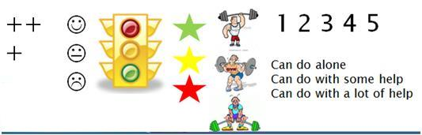

The second aspect of these enhancements is providing learners a physical place to self-assess their ability in relation to the Can-Do statements modified from NCSSFL’s Can-Do’s in the unit plan. Encouraging accurate self-assessment is essential. We can accomplish this using a number of visual representations (see Chart 1): check mark system (+), smiley system (), stop light system, star system, number system, or weight system. These are all designed to help learners more precisely answer this question: Can I … (e.g., identify pictures of Russian food)? The answer is yes – but with what degree of autonomy? Can I do it alone? With some help? With a lot of help?

You’ll notice that both the poster and the handout enhancements require learners to self-assess their ability twice for each task, before and after the task is performed. The pre-task assessment informs learners of the task and provides them with a reference point from which they can gauge their growth. On the post-assessment, learners see both their current ability to complete the task and their perceived language growth. Even for younger learners, the latter has a strong effect on increasing learner motivation. It sends a powerful message that, through effort, we increase our ability in a world language, a key factor in learner persistency.

The poster is a great public display of learning objectives and self-assessments that can be filled out as a whole-class activity. In the handout, learners can include evidence they produce in class that will become their individual Dossiers. Having both a poster and a handout is ideal, providing your learners the ability to self-assess twice for the same tasks. While the poster is used for a more global, unit-level, integration of the LinguaFolio®, the handout can be used to support LF® implementation on a more local, task level.

The handout we use with our transitioning learners is designed to further focus on LF® implementation at the task level. The example in Appendix 4 is a good template that can be changed according to your needs. Similar to both the poster and the K-2 handout, realia illustrates the unit theme and there is space to self-assess before and after the task is performed. However, this handout is specific to one of the Can-Do statements adapted to the unit in step 1. Below the self-assessment, we include space for learners to explain the task they chose and to reflect (either visually or in written form) on what they liked about the task. After creating the template for this handout, adapting it to the different tasks is only a matter of switching out the Can-Do statements. Hence, with our transitioning learners, we produce one handout for each of the Can-Do statements that will be evidenced in the Dossier of the LinguaFolio®.

Taking the unit plan a step further to create these enhancements is essential for effective LinguaFolio® integration. Steps 1 and 2 are designed to prepare for successful LF® implementation. Next, we will explore effective LF® use in the classroom.

Step 3: LinguaFolio® Jr. in the Classroom

Remember, the primary objective in engaging learners in LF®use is to help them become more autonomous learners. Learners slowly increase the degree of control they have over their own learning process over time. We do not expect our young learners to become fully autonomous by the end of our unit; it is our goal to lay the foundation for success. The largest factor in the success of LinguaFolio® implementation is you, the teacher. In Steps 1 and 2, we concentrated on preparing ourselves for success. Now, we turn to examples of in-class activities for integrating LF®. For this purpose, we will continue with our example. But first, think back to our five year old in the car: Where are we going?

One of the first activities on your first day of class will be introducing the enhancements made in step 2. We start with the global-level poster. A great way to introduce learners to the unit theme is through elicitation. Show learners the poster, but instead of telling them your unit theme, have learners guess. Sometimes referred to as the Socratic Method, asking questions actively involves learners in the learning process. Our job is to guide the conversation. For example, point to some of the pictures and ask, “What is this? Good. And, what is this? OK. What will we learn about these?” Some learners may already know what some of the images are in the target language. This short discussion will animate your learnes. Using the poster, this is also a good teaching moment to introduce learners to the target language’s alphabet as you help them write their names.

Introduce learners to the tasks at this time as well. Of course, when interacting with young children, we must be cognizant of their attention span. A good way of maintaining attention is having them complete their pre-assessment of ability as you introduce each task because this requires them to be active participants. Scaffolding the process of self-assessment is essential, especially for early learners. Ask them questions: Can you … (e.g., point to the Solyanka)? If they claim to be able to accomplish the task, request that they demonstrate it. An advantage of using the poster is that this can be a whole-class activity. While self-assessing on the first day in front of peers may increase anxiety a little, peer accountability is positive. Alleviate their anxiety by giving an example. A great model could be using a doll or a puppet. Introduce the doll to your class and ask the doll if he can accomplish the task. If you feel your transitioning learners would not respond well to an inanimate model, after eliciting a task, ask your class if anyone can do this already and have your volunteer demonstrate. Then help your volunteer self-assess how well he or she did. This will both illustrate the task and inform other learners’ self-assessments.

Make sure to explain your assessment system (Red Star: needs a lot of help; Yellow Star: needs a little help; Green Star: needs no help). Potentially having three doll models (one at each level: red, yellow and green) would help illustrate the differences best. Require the models to explain the reason for their self-assessments. While we do not expect abstract rationales from younger learners, giving reasons is crucial to fostering accurate self-assessment (e.g., says what I want it to say, is real). With younger learners, it suffices to have learners give an example or a demonstration if they self-assess at middle or high ability. Once again, doing this as a class on the LF® enhancement poster will help inform learners of their own self-assessments. Also, knowing that if they choose to self-assess at a middle or high level will require them to demonstrate their ability will encourage truthful self-assessments.

It also is best to introduce and assess one task at a time, instead of first introducing all the tasks and then assessing all. This maximizes learner participation and attention. After finishing the pre-assessments, reflect a moment together on the poster eliciting once more from learners the theme and the tasks introduced. It is normal that some learners be more advanced than others. Validate the importance of prior knowledge, but reassure learners that all will be able to accomplish the tasks at the end of the unit.

After finishing with the poster, have learners return to their seats and introduce the handout. Learners will be able to quickly identify the unit theme and the first task. Have learners self-assess for this first task only. While the poster will serve as a global pre- and post-evaluation at the unit level, the handout facilitates the cyclical nature of fostering autonomous learning at the task level. Learners will benefit greatly from the routine practice, with the handout serving as a transition between tasks. On the first day, before we begin learning a new set of skills, we pre-assess. Then after finishing the task we re-evaluate. The goal is that we see tangible growth in our ability and that we attribute that growth to effort. On that same day that we look back at the last task, we collect our evidence to be included in the Dossier and look forward to the next task.

Strategies for self-assessment with the handout are similar to that of the poster. It is always good to model. This can be accomplished with dolls, peers or yourself, the teacher. However, peer models may be more effective than teachers due to the difference in the nature of the relationship between teacher-learner and learner-learner. Potentially a combination of models is most effective. For example, you could use the doll, or puppet, as a model first to help explain the assessment system. It also is important to include modeling giving reasons for their self-assessments. After showing the doll model, another good strategy is having learners use the buddy system. Similar to self-assessing as a class with the poster, using peer review via the buddy system will encourage accurate self-assessments. Make sure learners not only share their self-assessments but also their rationale, or demonstration. It is recommended that learners share before they fill in their handouts because this enables learners to negotiate their self-assessments. Providing, listening to and negotiating good reasons for accurate self-assessments are excellent exercises for all young learners, but particularly for transitioning learners.

Doing both of these self-assessments (the poster and the handout) on your first day of class lays the groundwork for successful LinguaFolio® implementation. Together they will take learners around ten minutes to finish both the global, unit-level poster and begin the individual task-level handout. After finishing the handout, begin with the input phase of your lesson. It is important to remember that not all of the activities you plan to engage learners in are included on the handout. Only the activities that can be measured are included. The cyclical nature of the handouts is directly related to the tasks included on your LF® enhancements to be evidenced in the Dossier of the LF®, not class days or lessons necessarily. Learners should post-assess following completion of the task as soon as possible so that their work is still fresh in their minds. After reflecting on their last task, they pre-assess on the following task. This closure and preview provides a wonderful transition between tasks. Hence, the handout is not tied directly to specific lessons, or class days; it is tied specifically to the tasks you include on it. Both the evidence and the LF® enhancement handout are to be included in the Dossier section, as the handout serves as a record of self-assessments and a table of contents.

A good routine generally, but also specifically for those days that one of the tasks included on your handout is not accomplished, is to use the poster as an opening and a closing to your lesson. This does not require learners to self-assess, but gives them a quick preview of what to expect and review of what has occurred. This will remind learners where we are going (learning objectives), why we are doing what we are doing (purpose of the tasks), and if we are there yet (have reached our learning objectives).

Another integral part of the LinguaFolio® is fostering the capacity to set and reflect on goals. With older learners, the goal is that they play an active role in deciding the tasks to illustrate their emerging abilities. Giving learners choices entices situational interest, thereby making learning more exciting and fun. We do not expect younger learners to decide how they wish to apply the language (the tasks), but we can provide them with real choices (the details). In our example, for our first Can-Do statement (I can identify pictures of Russian food), instead of learners circling food that you, the teacher name, learners could work in pairs and circle the food that their partner names. This small variation gives learners a small degree of control over their finished work and creates a more learner-centered atmosphere. Our second Can-Do statement (I can ask friends what they like to eat), allows for a lot more control. Learners can choose which foods they wish to survey their peers about and potentially also how they wish to present their results graphically. Even small choices, like which colors they wish to use to fill in a graph you provide them, are important to young learners.

When introducing the task, make sure learners know what is required and what their choice is. Talk learners through this process. Once again, using a model, potentially in puppet form, is a great way to inform learners what they need to do and what they need to decide. In our example, while making the transition from input phase to practice phase, you could reintroduce the doll that helped to inform the learner how to self-assess with the LF® enhancements and tell him you are ready to start the project. In clear speech, explain what you need him to do (e.g., “We are ready to ask our friends what they like to eat in Russian. First, you need to choose three foods you want to ask about. Which foods do you want to choose?”). If you do not wish to use a doll, you could also do this with one of the stronger learners. After modeling, monitor learners as they tell their partners which foods they choose. It is a good idea to ask learners what they have decided as you monitor their peer conversations.

To maximize choice with our transitioning learners, potentially you could let learners actually decide the task. Perhaps instead of creating a chart illustrating their peers likes or dislikes of Russian food, they would rather draw pictures or write a story. Certainly there are many ways to express likes and dislikes. Brainstorming different ideas as a class is a necessity. Make your requirements clear (e.g., “Your project must include at least five different peers’ likes and dislikes”). If allowing learners to individually create different projects is too confusing for your learners, you could still decide as a class on one class project to be completed by all learners. And if no ideas are produced through brainstorming, you always have your back-up plan (e.g., creating the chart).

Using peer groups like this is a great way to support both the decision-making and the reflection process. After finishing their tasks, ask learners to explain their finished work to their partners. In more advanced classes, this also is a great way to practice the third person in the target language. A good way to facilitate peer reflection is by asking learners to evaluate their partner’s work, telling them one thing (or more) they like about their project and offering one suggestion to make it better for next time. While some of the feedback may be trivial, the goal with younger learners is to start to build the foundation for goal setting and reflection.

After finishing the peer reflections, it is time for learners to post self-assess their ability to complete the task using the handout enhancement. Especially after finishing the first task included on the handout, it is pertinent to remind learners what the different self-assessment icons mean. In accordance with the cyclical nature of LinguaFolio®, this also is the time to pre-assess for the next task. Collect learners’ finished products in a folder (digital or paper) so that they can be included in the Dossier section of the LinguaFolio®.

At the end of the unit on the last day of class, bring learner attention back to the poster enhancement. Once again elicit the unit´s theme and the tasks learners have completed. Now it is time for their final post-assessment. As with the pre-assessment, provide learners with a model and complete the post-assessment task-by-task instead of introducing all the tasks at once. Reviewing your unit goals is a great way to remind learners what they have learned and close the “chapter”. Make a point to reflect on the collective growth and to congratulate learners for their achievements.

Before leaving step 3 on implementing LinguaFolio, it is pertinent to address integrating interculturality into instruction. As mentioned in step 1, the Can-Do statements addressing cultural awareness are to be treated very much the same way as the more language-oriented Can-Do statements in the enhancements and in the tasks we use for evidence. These culturally related Can-Do statements are not meant to be taught in isolation from the language (e.g., I can introduce myself in a culturally appropriate manner). However, just as we do not attempt to engage learners in detailed grammar instruction, interculturality cannot be directly taught to young children. It is more appropriate for young learners to focus on products and practices than on perspectives. This is a time to plant the seeds of awareness of one’s own and other’s cultures in developmentally appropriate ways. Here is some guidance on how to build interculturality in young learners:

Interculturality is a dynamic process of active participation in communication, guided by an awareness and understanding of culture.

Along with language development, interculturality plays an integral part in the goal setting, self-assessment, and reflection process of LinguaFolio®. In preschool through grade 2 the child’s role with LinguaFolio® is more passive than active, but particularly so in regard to interculturality. Older elementary children transition to a more active role. For young children, ages 2-7, their self-identity is under construction. This is the time to build, in developmentally appropriate ways, awareness of one’s own culture. It is also the time to expose children to elements of other cultures, so that in forming a self-identity they may more naturally include diverse elements in their own identity.
Most early childhood pedagogy is inspired by the work of Jean Piaget whose focus was on the ways children process knowledge. Piaget’s second of four stages, the Pre-Operational stage (ages 2-7), describes how children experience things from an egocentric view, failing to understand how someone else’s point of view might be different from their own (Campbell, 2006, p. 5). During this stage, children build an awareness of culture based on their immediate environment. They are keen observers of objects, actions, and attitudes that teachers recognize as the products, practices, and perspectives of the national standards. Preschoolers especially tend to process knowledge by repeating, imitating, or mimicking what they see and hear. Teachers can capitalize on this natural tendency by providing an environment of cultural authenticity as well as opportunities for interaction. Social interaction, according to Vygotsky, allows children to experience new things that become familiar and comfortable to them. This familiarity leads to internalization. “When the cultural signs become internalized, humans acquire the capacity for higher-order thinking” (Blake and Pope, 2008, p. 61).
As learners progress in their language learning and cognitive development, their competencies will evolve through the “five saviors” as described by Michael Byram. This facilitates the development of intercultural skills in negotiation and mediation and provides a framework for developing analytical, reflective, and critical-thinking skills. At this stage, however, the focus of P-5 classes should be on language development in contexts that build an awareness of culture. The role of teachers is key, as described below:
- Cultural goals can best be met by giving learners experiences with the culture rather than by talking about cultural facts and artifacts. Many of these experiences can be part of daily classroom activity, integrated with the use of language in an authentic, communicative setting.
- Teachers may identify cultural information to integrate with language and subject content by considering the categories of cultural products and practices and considering the perspectives they represent.
- In all cases, culture requires careful and systematic planning, to provide developmentally appropriate information and experiences at each developmental level and a well-designed sequence of instruction.
- As teachers plan lessons that incorporate cultural products and practices, they are also building a foundation of awareness of the perspectives of the culture. Although perspectives may not always be overtly taught, the teacher needs to be aware of the perspectives underlying the cultural experiences of the classroom. Guiding learners in the comparison of cultures helps them develop a deeper and more personalized understanding of both the target culture and their own culture (Curtain and Dahlberg, 2010, p. 278).

To summarize, implementing the interculturality piece of LinguaFolio® is managed differently with elementary school learners than it is with middle and high school learners. It is more appropriate for young learners to focus on products and practices than on perspectives. Developmentally, the metacognitive skill of understanding perspectives is possible, but expressing this phenomenon will evolve when language skills are more developed and cognition more evolved.
At this age and stage of language learning, it is important to:
- Establish a sense of self, and a sense of one's own culture.
The world language teacher, learning facilitator or parent guides the learner in this process. Ways in which this may be accomplished are to:
  - Access the learner's background knowledge as one would do in any learning experience. This puts the learner at ease, lowers the affective filter, and prepares the learner to accept new ways of thinking and acting. One might ask questions that allow learners to recognize party hats and noise-makers as symbols of a New Year’s celebration, then they would be introduced to red money pouches of China.

  - Use what learners are familiar with so that they can begin to identify elements of their own culture before they are asked to recognize elements of another culture. Such examples might be using the cultural products of birthday cakes and greeting cards; the practices of eating with knife, spoon, fork; or playing basketball or baseball rather than specific examples of the target cultures products and practices. When introducing the theme of family, the learner focuses first on his/her own family or that of a family from the home culture familiar to all. A teacher, learning facilitator or parent can stimulate learners’ senses to engage their imaginations in order to give them a cultural experience rather than directly instructing them about culture (NNELL).

- Model rather than explain.
Modeling enables the learner to infer meaning through the input of the target language and without the intrusive use of English. Young learners notice more of what is done than what is said. Their tendency to mimic language and imitate behaviors provides the practice to embed the learning. An example in an Arabic class might be to eat with his/her left hand rather than explaining that this is a common practice.
  - Strategically use the cultural practices and products associated with the target culture.
For example, when introducing the practices of the culture:
    - If in a classroom setting in the target culture learners stand/bow and speak a traditional greeting, then teachers establish that practice as a routine.
    - When counting, teachers count on their fingers as is done in the target culture. Modeling eliminates the need to explain.
    - When treating the theme of meal-taking, teachers use the utensils and motions as is done in the target culture, thus again eliminating the need to explain.
When introducing the products of the culture:
    - It is helpful to access prior knowledge by first selecting visual representations or objects of items in the learners' culture (U.S.) and then relate them to those of the target culture. For example, one might show a loaf of bread from the U.S. and then one from the target culture.
    - Games and rhymes are intuitive, so selecting authentic games and rhymes from the culture are more effective than using translated versions of American games/rhymes because it immerses learners in the target culture and language.
    - Because the concept of calendars is unfamiliar to very young learners, the teacher might prefer using American calendars first and then one of the target culture to establish transferable knowledge.

- Establish a safe environment for discovery and inquiry.

- Focus the learner on noticing what is, not what is different;
- Draw attention to commonalities.
- Encourage reflection. Ask questions, but don't require answers. This is a time when seeds of thought are planted in the learner’s mind that later allow them to understand perspectives. For example, a teacher might ask in the target language, why do we do … and they do …? Plant the seed of reflection.

- A Starburst on the side of the STARTALK LinguaFolio Jr. poster could be used for learners/teachers to put in evidence of experiences with products and practices of the home culture or the target culture (new awareness);

- For example, the teacher puts in the targeted cultural experiences with products and practices, such as (1) played ping pong, (2) tasted authentic food, etc. and then the learners will add their own.

Conclusion

In step 1 we saw how LinguaFolio® can facilitate the creation of a comprehensive unit plan. In accordance with best practices in “backward design”, we start with the end in mind and work back to the individual tasks that will lead us to our learning goals. Focusing on communicative objectives illustrated by our modified Can-Do statements helps us concentrate on learner-centered classroom activities. Allowing learners the ability to choose some of the details of our tasks encourages their active participation and fosters goal-driven behavior.

In step 2 we created a personalized enhancement to the LinguaFolio® that informs learners of our overall class theme and the tasks learners will complete along the way, providing learners with a roadmap to success. Also integral to LF® implementation, these enhancements are the physical place where learners record their pre and post task self-assessments. Two enhancements, the poster and the handout, allow you to integrate LF® at the more global unit level and the more tangible lesson or task level.

In step 3 we explored some practical tips for integrating LF® into the classroom, focusing on strategies for goal setting, self-assessing ability, and reflecting on linguistic and intercultural evidence. A reoccurring theme was scaffolding these processes through the use of models (teacher, peers, and dolls). Using clear language and breaking tasks down into smaller steps were two other constructive suggestions. Throughout the integration of the LF®, it is helpful to view LF® use as a cyclical process. The work done in steps 1 and 2, creating your unit plan and enhancements, will provide you with a clear path to success in step 3.

We started this LinguaFolio® teacher guide with the analogy to the traditional Russian babushka dolls referring to the way our tasks nestle into our lessons, into our unit plan, into our modified “I can” statements, into NCSSFL’s Can-Do statements. It is our hope that this vision has been effectively transmitted. LinguaFolio® should not be seen as something external to our lesson. LinguaFolio® should also not be perceived as limiting or controlling. It does not dictate unit themes, lesson plans or classroom tasks. LinguaFolio® provides you with a pedagogically sound base from which you are free to modify and mold as needed. Likewise, the enhancements included in this teacher’s guide are simply examples that you may modify to your needs.

Similarly, LinguaFolio® seeks to empower learners as well. The goal of LF® is to foster autonomous learning. This happens through informing learners of our learning objectives, allowing learners the freedom to modify these objectives to their interests (choice), and fostering accurate self-judgments of ability in relation to finished products. Fostering learner autonomy is a slow process that, especially with younger learners, requires adequate scaffolding. Use the tips included in Step 3 to help you accomplish these goals.

It is our hope that this LinguaFolio® Jr. Teacher’s Guide will help you lay the foundation for the future success of your learners. Please consult the resources below for further information.

Bibliography

Blake and Pope, (2008). Developmental Psychology: Incorporating Piaget’s and Vygotsky’s Theories in Classrooms (p. 61) Journal of Cross Disciplinary Perspectives in Education, Volume 2 1, No.1, May 2008, pp.59-67.

Campbell, R.L. (2006). Jean Piaget’s Genetic Epistemology: Appreciation and Critique. http://hubcap.clemson.edu/~campber/piaget.html
Cleary, T. and Zimmerman, B. (2004). Self-regulation empowerment program: A school-based program to enhance self-regulated and self-motivated cycles of student learning. Psychology in the Schools, Vol. 41(5). Published online in Wiley InterScience (www.interscience.wiley.com).

Curtain, H. and Dahlberg, C.A. (2010). Languages and Children —Making the Match: New Languages for Young Learners, Grades K-8, 4th edition. Boston, MA: Pearson Education Inc.

http://www.learnnc.org/lp/editions/LinguaFolio. Module three, student reflections, elementary student video.

https://maestranadine.wikispaces.com/Giving+Kids+A+CAN+DO+Attitude%21
https://maestranadine.wikispaces.com/We+Can+Speak+Spanish+At+Dunn+Elementary%21

Appendix 1
Unit Name (What do you like to eat?)

Outcomes
I can say the names of familiar people, places, and objects in pictures and posters using simple words or memorized phrases.
I can understand some simple questions on familiar topics.
I can answer questions about my preferences using one or more words or memorized phrases.
.
.
.

Lesson # | I can … | Evidence
1 | Identify pictures of Russian food. | Learners circle pictures of people eating different foods according to teacher (or peer) instruction.
2 | Ask my friends what they like to eat. | Learners decide on three foods they wish to survey their peers about and fill in a graph with peers’ answers.
.  .  . | .  .  . | .  .  .

Appendix 2
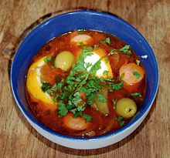
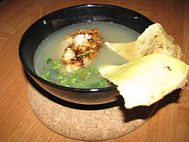
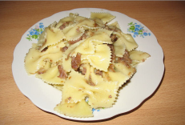
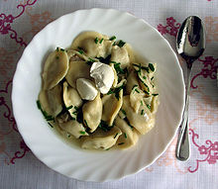
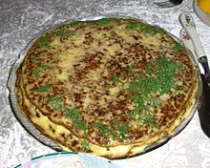

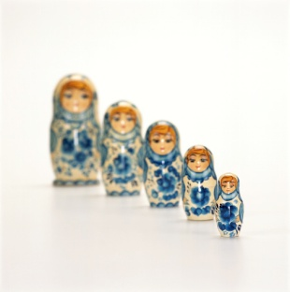
Learners’ Names |  |  | 

Appendix 3

Меня зовут:
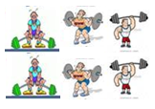

Appendix 4

Меня зовут:
I can __(e.g., ask my friends what they like to eat)_________.

Before After

What did you do to show you can do this?

__________________________________________________________

Show and Tell:
Draw a picture or write about what you liked about your work.
Adapted from LinguaFolio Jr. Washington K-4
Appendix 5

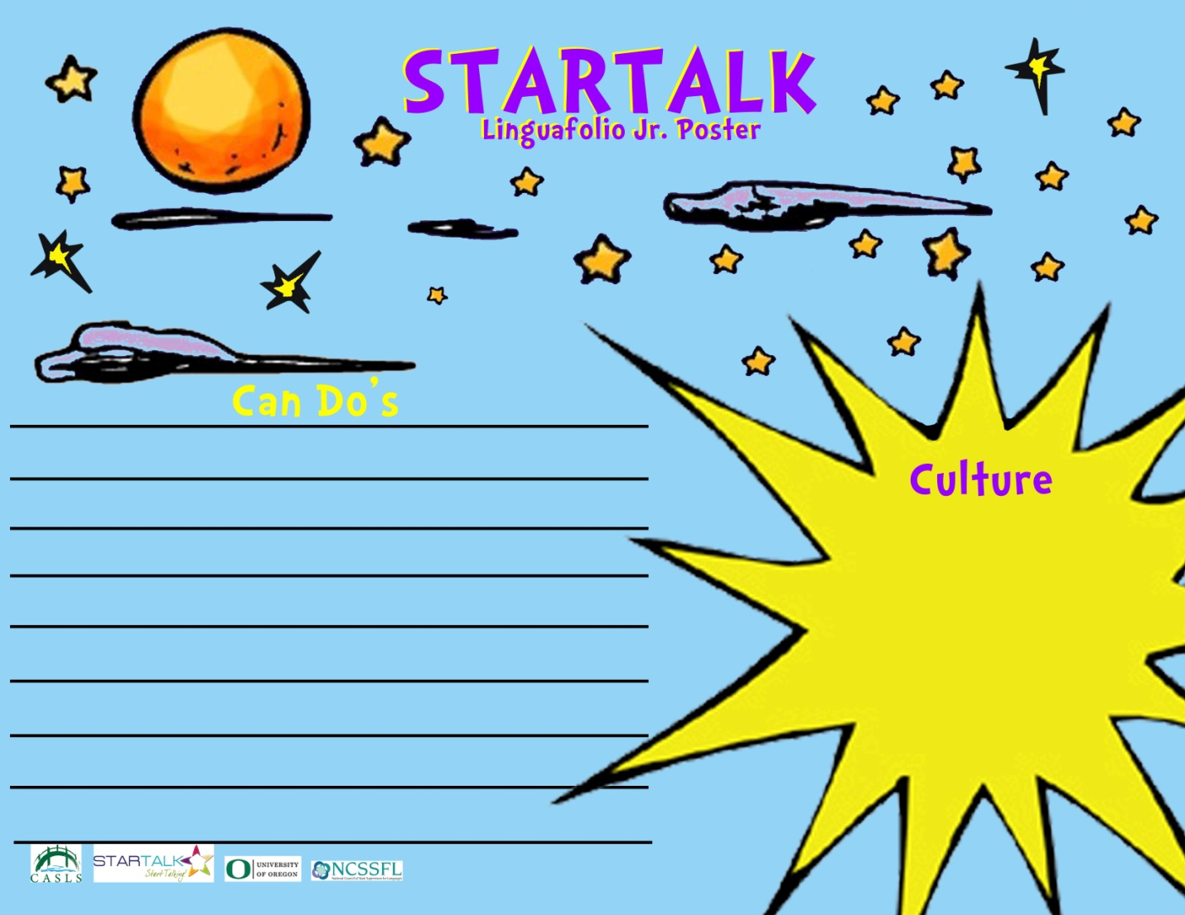

Appendix 6
